INDEX
S.No. | Contents | Page No.
1. | Introduction | 1
2. | Objectives of the project | 2
3 | Assessment | 2
4. | Needs observation | 3
5. | Field visits | 4-26
6. | Industrial visits | 27
7. | Institutional visits | 28
8. | Official meetings | 29
9. | Action plan | 30

INTRODUCTION:
More women and girls constitute people who suffer from poverty in India than men and boys (World Economic Forum 2019). Hence development projects often focus on the economic empowerment of women. Reimagining Women Empowerment Program is an initiative to increase women’s access to economic resources and aims to enable them to make financial decisions that benefit them, their families and the society at large. The women of Thoothukudi possess traditional knowledge and skills, which are currently being utilised to develop products like palm baskets, clay pots, artificial jewellery, etc. The district administration has also been involved in reskilling and upskilling these women through various programs.
The need of the hour is to bring about a transformation in the role of women - from mere service providers to entrepreneurs capable of owning and managing the entire supply chain from procurement of raw materials to selling the goods in physical and digital markets. Kaani nilam and Young People for Politics (YPP) with the support and involvement of Kanimozhi Karunanidhi, Member of Parliament, aims to achieve this by enabling and widening the access of women to market structures, both physical and digital, hand-holding them through the process of digitisation and supply chain optimisation and by facilitating them to take ownership of the entire endeavour.
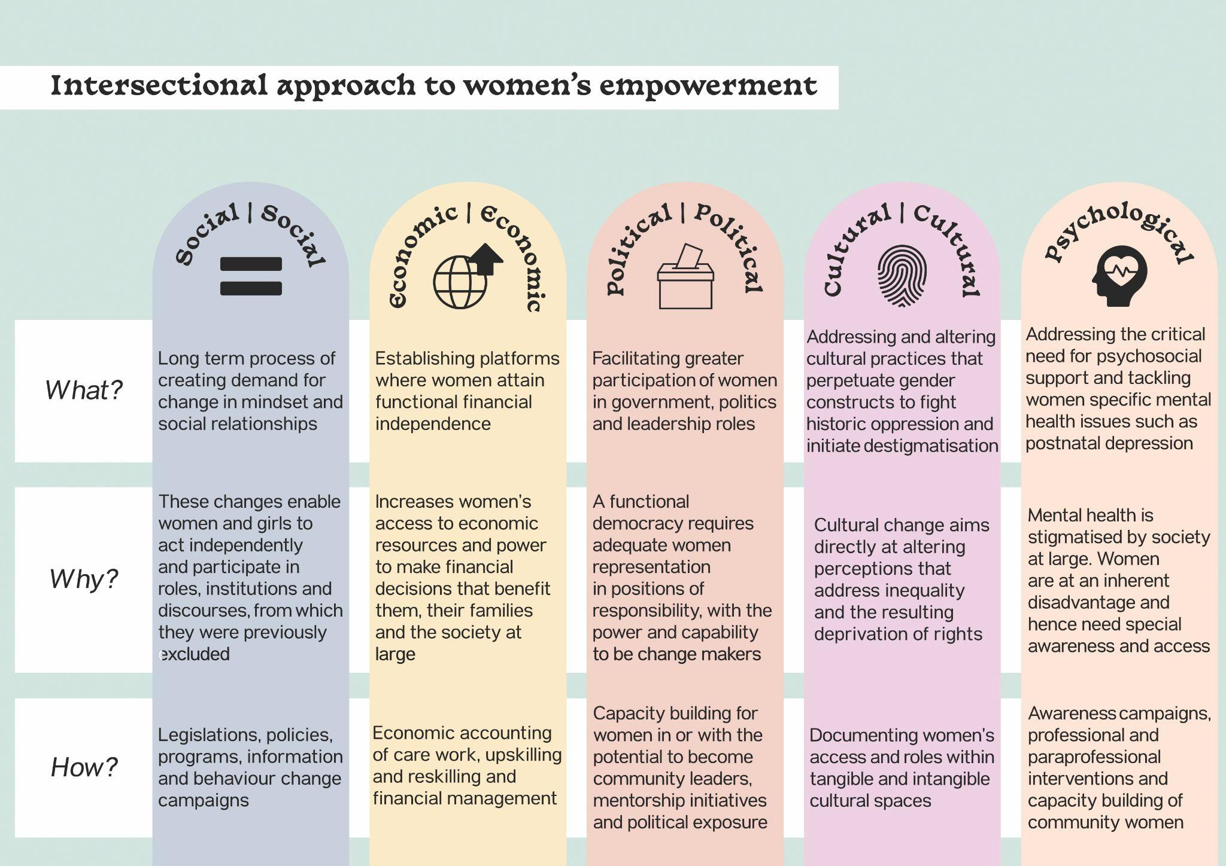
OBJECTIVE OF THE PROJECT:
To create an Integrated digital and physical marketplace to promote, sell, and preserve artisanal products produced by women of Thoothukudi.
This project intends to identify, document and harness traditional knowledge that women possess and build capacity in them to develop new/better products, acquire deeper skills in manufacturing, understand and respond to market demands, become financially equipped and manage the entire 'artisan producer to consumer' chain by themselves.
The three focus sectors will be:
- women in agriculture
- women in handicrafts
- women in fisheries.
ASSESSMENT:
Kaani Nilam and YPP visited Thoothukudi from 13.08.2021 to 22.08.2021 for field visits before the launch of the project. Pre-visit assessments were made through secondary data collected from the district administration and appropriate sources.
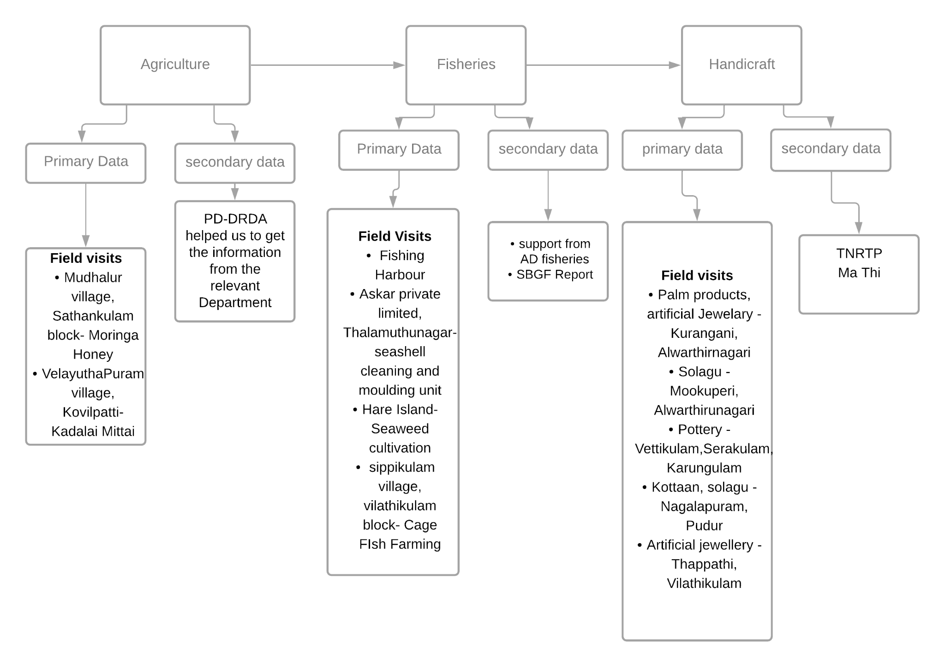
NEEDS OBSERVATIONS:
- Need for documentation of oral histories, narratives and associated culture practices
Eg:Fishing - Amba Paatu
- Classification of the clusters into two -
a. Clusters with indigenous knowledge
b. clusters with acquired knowledge
Training and capacity building to be organised based on individual needs of the clusters
- Though participation of women is high, their ownership is low
- Need for innovation in product designing
- Lack of marketing skills, hence lack of access to market
- Government programmes often fail to address socio-cultural aspects of women's lives that adversely affect their access to work. Eg: Childcare
- Occupational hindrances that adversely affect the supply chain must be addressed by the district administration.
Eg: Issue with access to clay and soil for the pottery cluster
- There is no quality branding for the products made, hence there is close to zero visibility in the market. Only the government has access to this information and their products.
- Integration of the most marginalised sections of the population - SC, ST and muslims - is visibly low in existing programmes. Special efforts need to be made to target women from these communities.
- Need for building community women leadership to facilitate direct engagement with administration and other power structures
- Currently the communication channel is one way, programme officer to women, there is a critical need to expand and create two way channels
- Lack of network among clusters within Thoothukudi has to be addressed to bring in coordination and sharing of best practices
- Integrate women clusters with the district tourism plan to widen economic prospects
- Access to digital markets through capacity building. Cultivate interest, skills and handhold next generation artisans to assist communities integration into digital markets.
- Need for innovative interventions to address occupational and sociological issues; policy level interventions, administrative interventions, technological interventions and civil society engagements

FIELD VISITS:
Place: New Fishing Harbour Date: 14.08.2021
City: Thoothukudi
Cluster: Fisheries
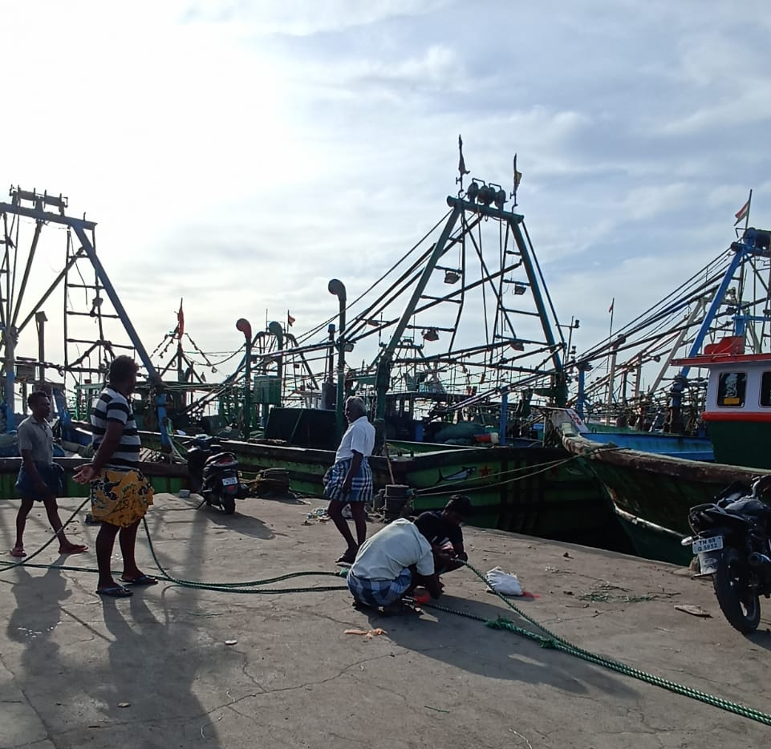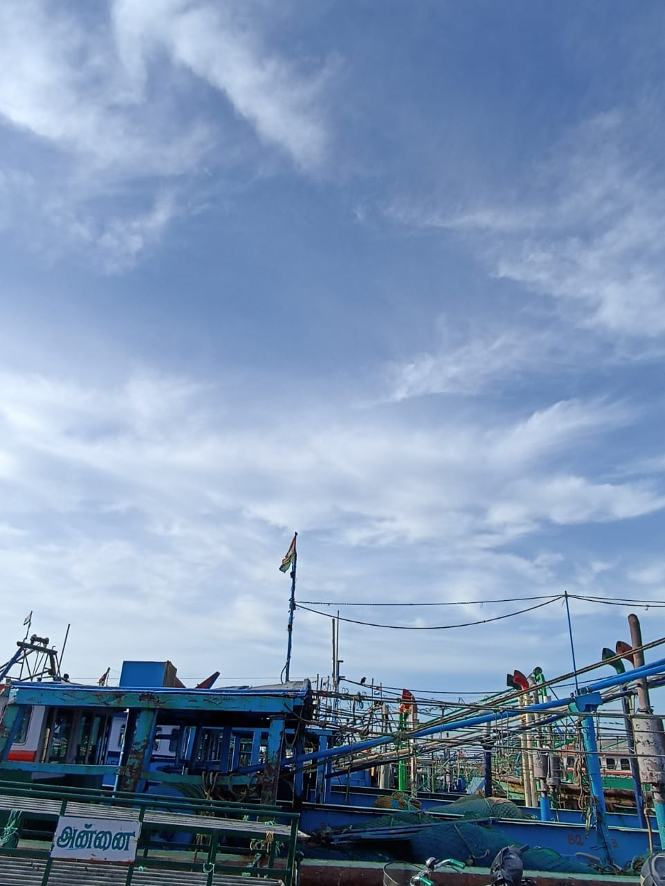
Trawler Boats landing Jetty - Thoothukudi
Team Kaani Nilam visited the Jetty, the fish landing center of Thoothukudi Fishing Harbour. It is one of the oldest fishery ports on the east coast of India. The fishing time is restricted between 5.00 am and 9.00 pm. The auction process is carried out in and around the auction hall, managed by the fisherfolk society along with the department of fisheries. During the day, this auction hall is used by the net makers to prepare and mend fishing nets.

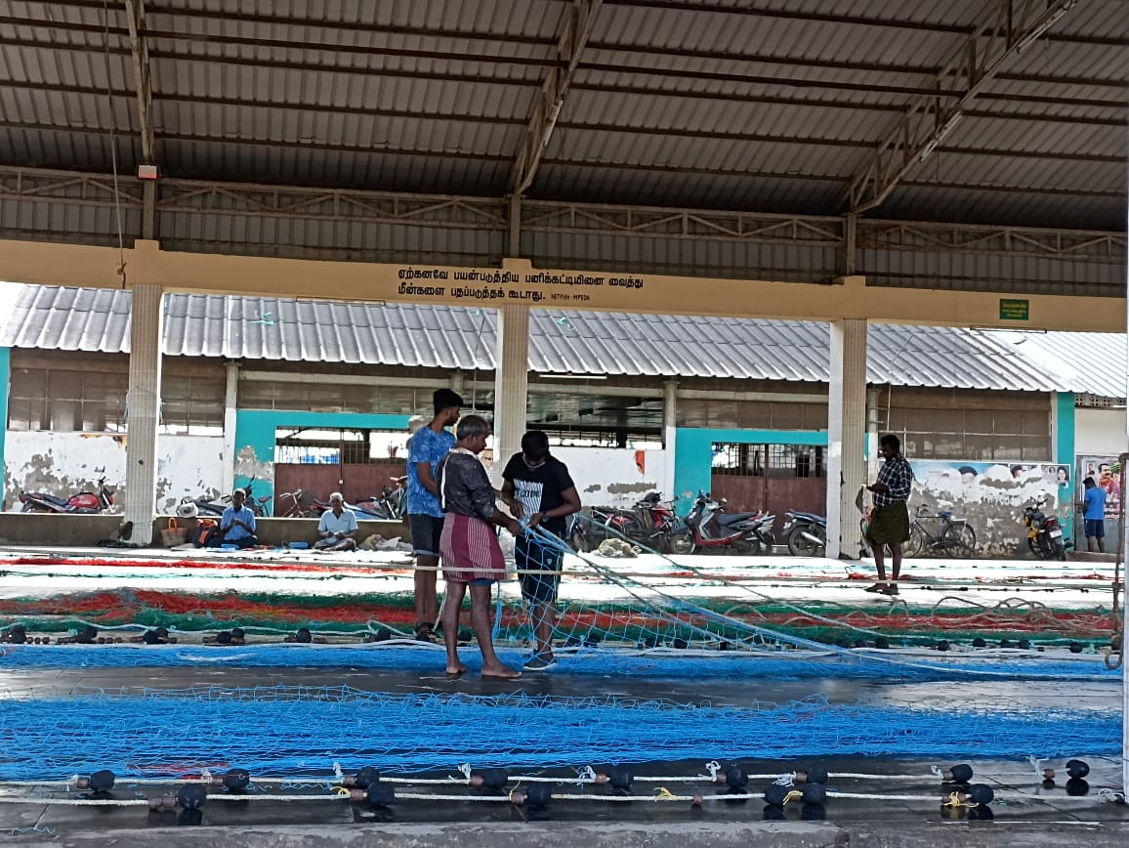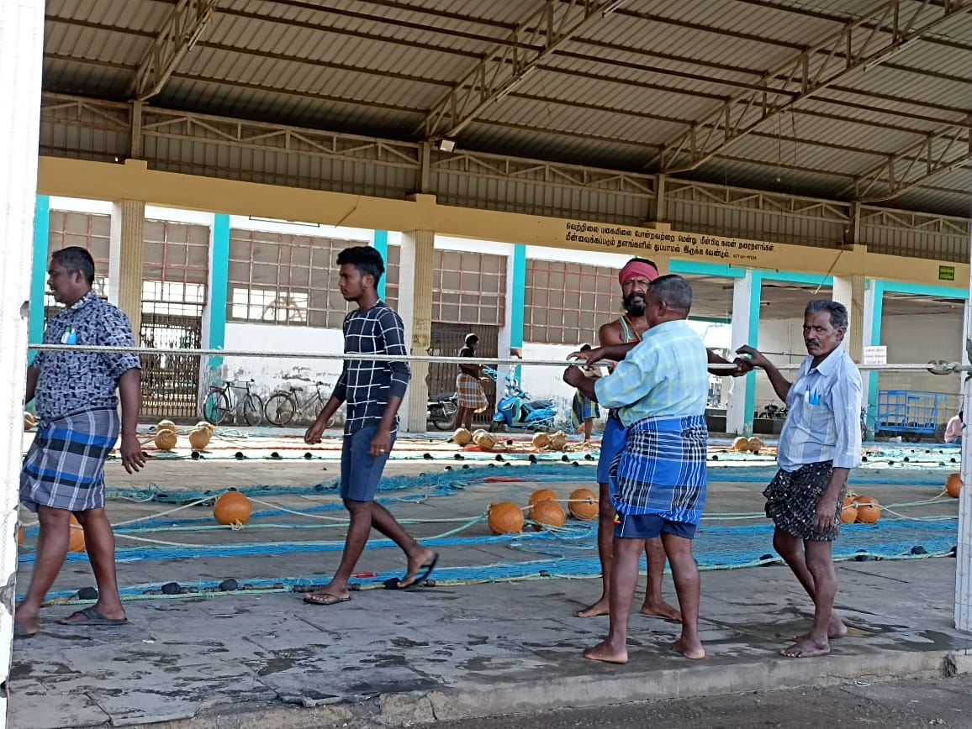
Net making in the auction center during day time
Mr. Irudhaya Raj, a fisherman from Therespuram, said that only mechanised boats land in this Harbour. About 400 licensed trawler boats arrive at this harbor every day that employ around 8000 people. The majority of the fishers in Thoothukudi belong to the Paradhavar community with clear boundaries set for fishing with neighbouring villages. Rayan Fernandas, a net maker, discussed the process of creating nets, which employs approximately 30 people and is an integral aspect of the sector.
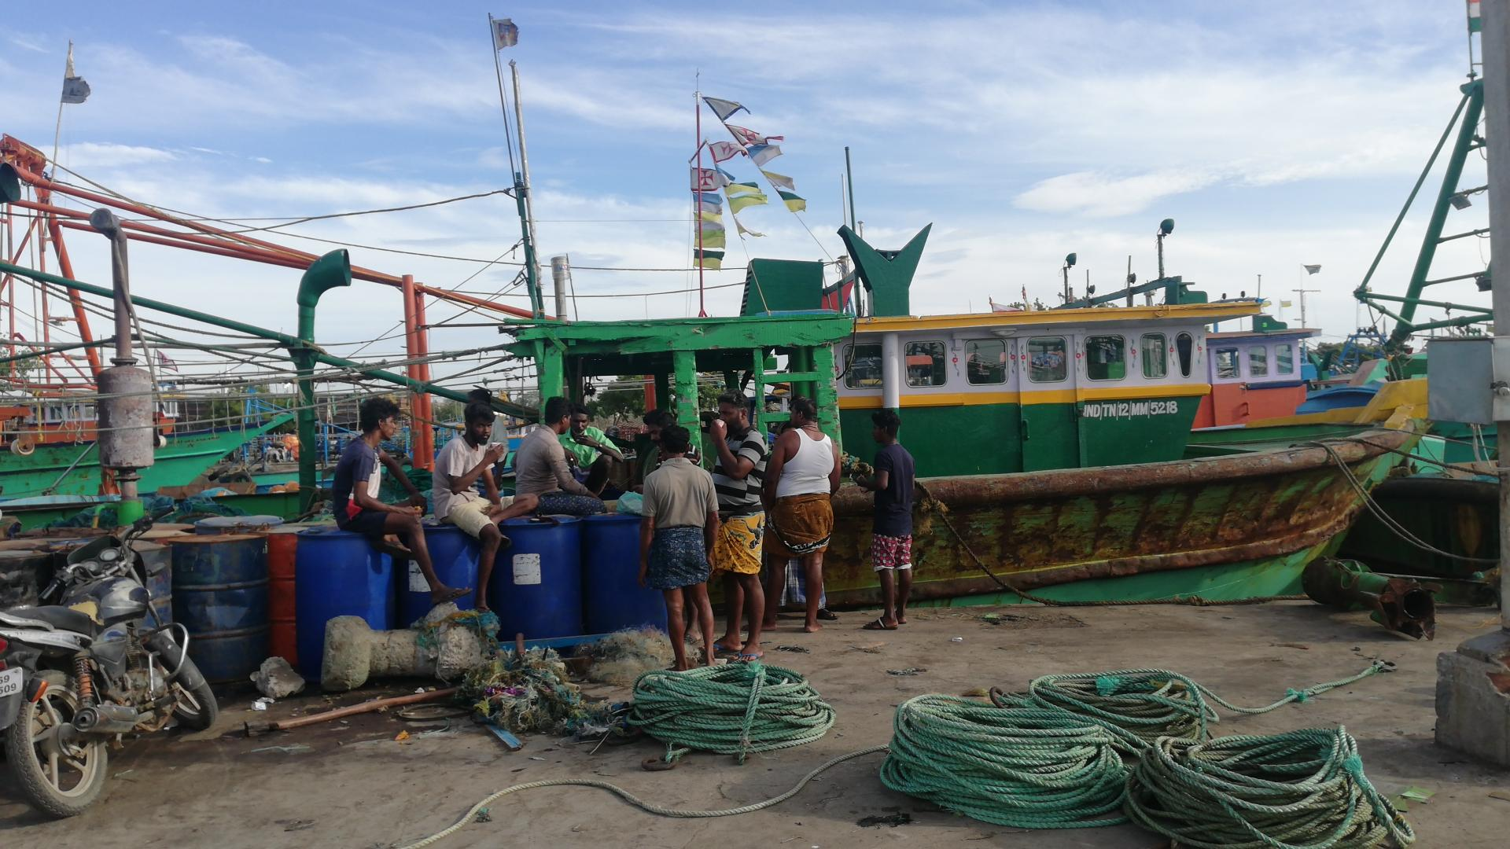
Fishermen resting at Jetty
Irudhaya Raj noted that the fishing community does not want the next generation to continue this occupation, since ways to improve their quality of life are meagre.
Village: Kamanayakkanpatti Date: 15.08.2021
Block: Kayathar
Cluster: Agriculture
Kamanayakkanpatti is a village in the Kayathar Block of Kovilpatti Taluk. It is well-known for the annual ‘Our Lady of Assumption’ church festival, which takes place on the 15th of August. As per local residents, this church is also renowned for its unique practise called ‘Kumbudu Sevai’ a ritualistic dedication of circumambulation by prostation. Every year, over 1.5 lakhs people participate in this festival.
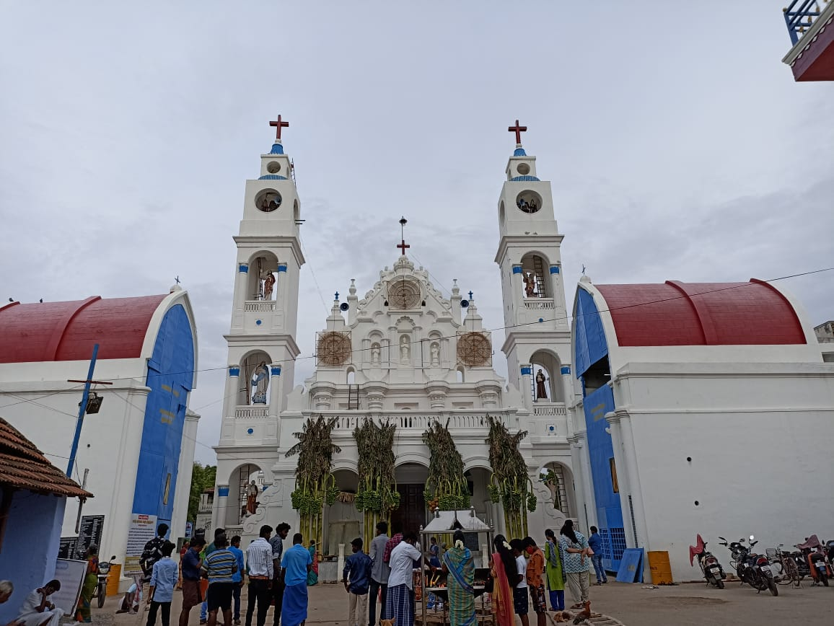

Kamanayakkanpatti Church
Mr. Devasagayam, an 81-year-old former Panchayat president of Kamanayakanpatti village, narrated the history of the community and church. According to him, the first church in Kamanayakkanpatti was built by Jesuit priests around 1600 CE. Christian missionaries offered education and health services to this hamlet. There are currently around 1500 families living in this Panchayat.
Mr. Anthony, Kamanayakkanpatti's Panchayat Secretary, spoke about the people's livelihood and the progress that they seek. Agriculture is the village's main source of income. Men go to construction work on the remaining days as it is seasonal.
Ninety percent of the women in this village have enrolled in the MGNREGA programme. The Panchayat will identify the work area and assign tasks to persons in that region. Women were employed in matchbox units that operated as a cottage industry in the late 1990s and early 2000s. With mechanisation taking away their jobs, they are entirely reliant on MGNREGA as their sole source of income.
Women of the village must be collectively organised in order to create sources for additional income utilising community resources.

Village: Kurangani Date: 16.08.2021
Block: Alwarthirunagari
Cluster: Handicraft
In Kurangani, our team met with members of the Self Help Group, who are also participants in the Tamil Nadu Rural Transformation Program (TNRTP). In Kurangani Panchayat, 10 Self Help Groups are currently operational. Handmade palm items such as colourful palm boxes, palm toys, palm baskets, and other palm ornaments are made by five women. TNRTP provided them with training in product development. Another member of the Self Help Group has received training in the creation of artificial jewellery. Because a significant percentage of women in these SHGs are from families that are landed and agrarian, they sell these items only to supplement their income and are not dependent on this as livelihood.
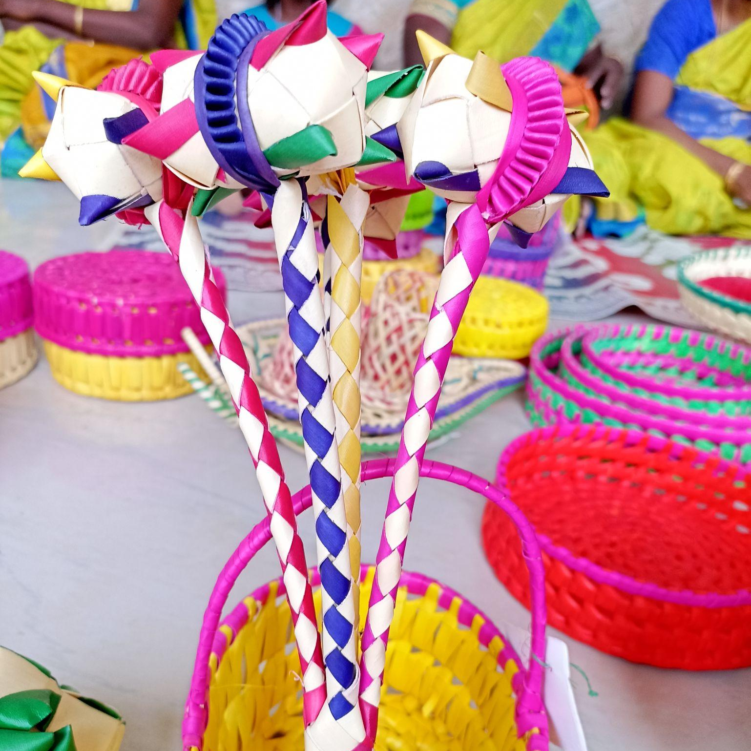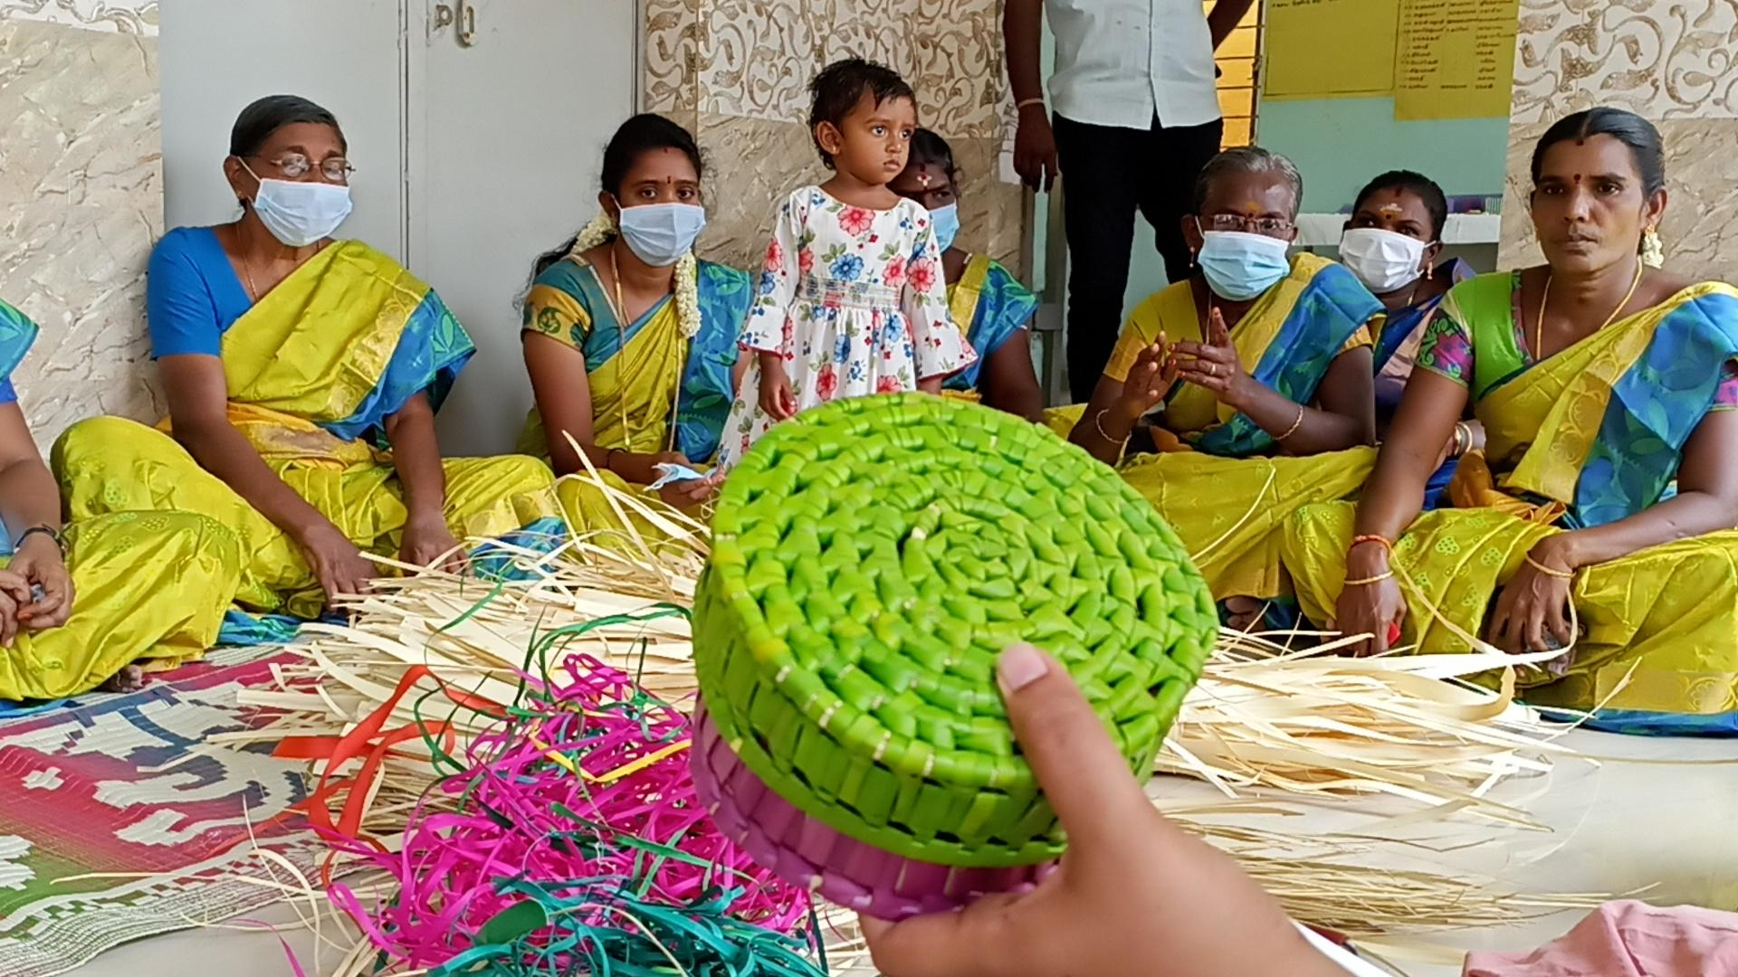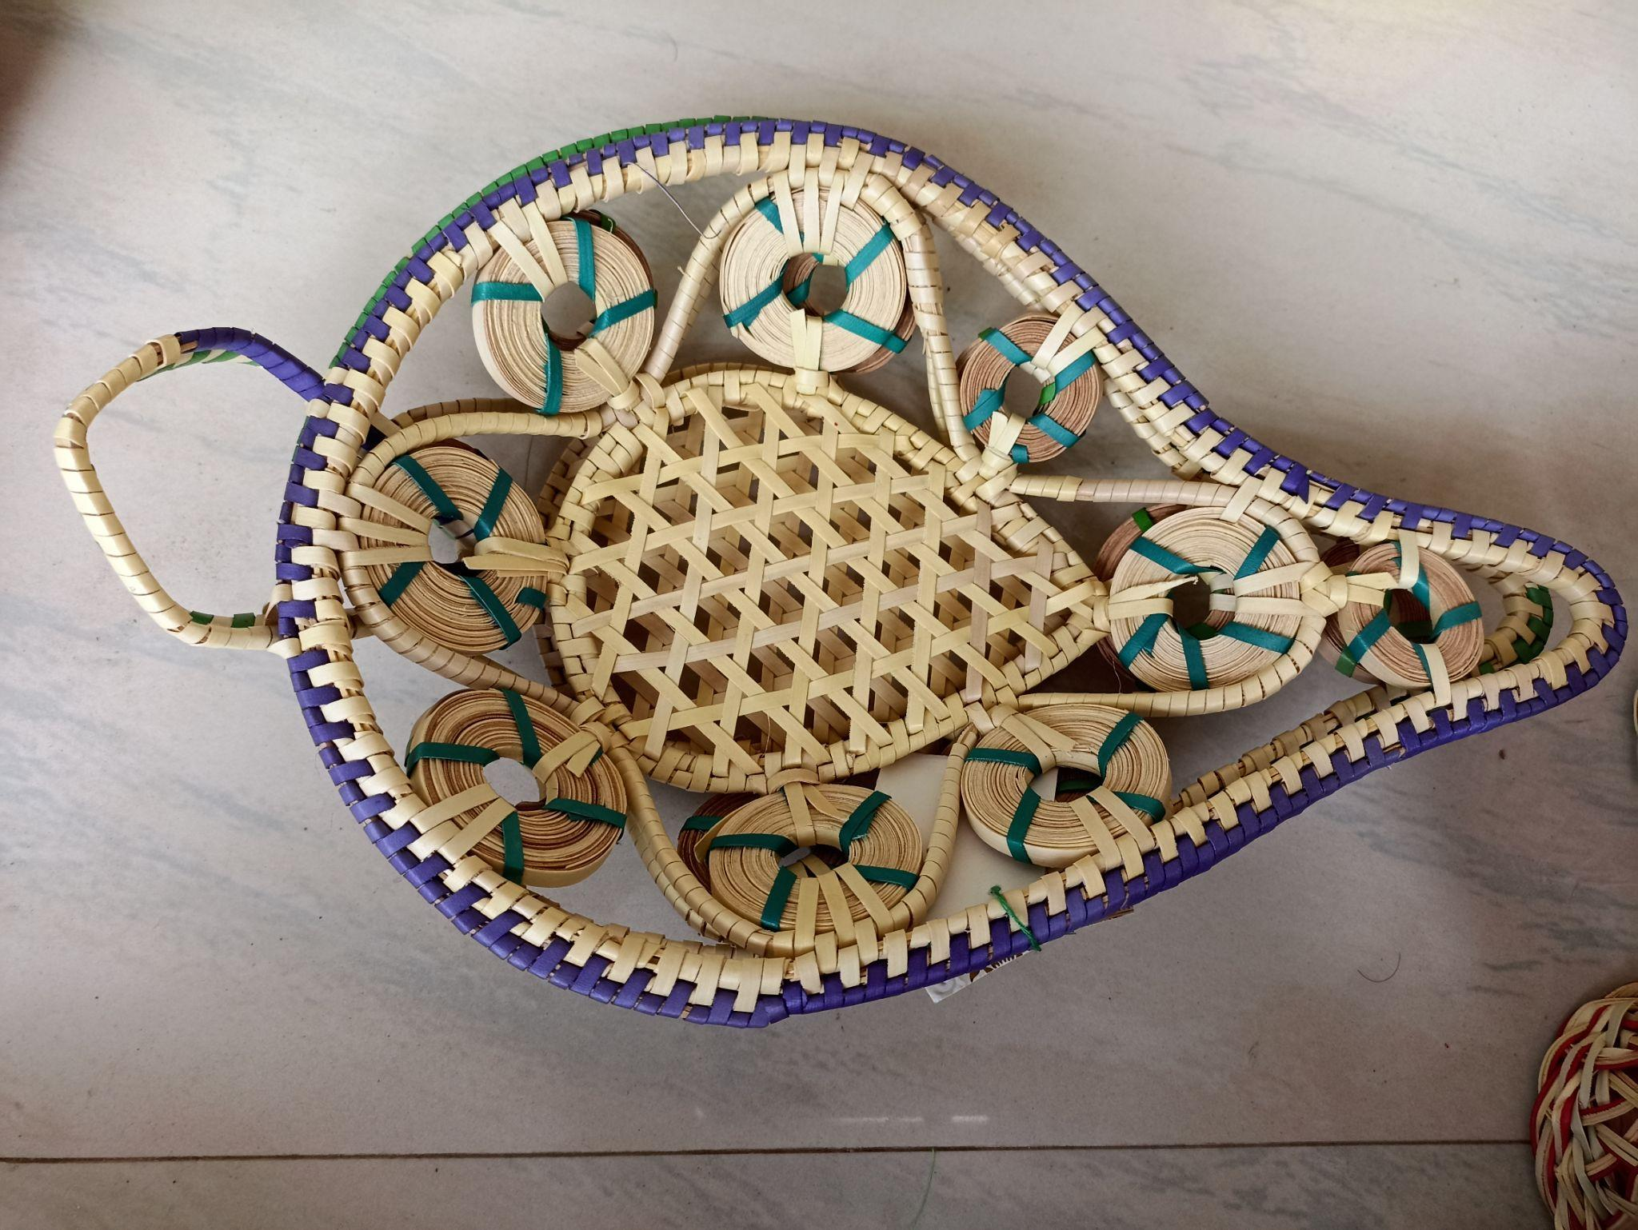
Palm products made by women in Kurangani village
The women need access to regular markets to sell their products. At present they don't have any physical or digital market space to sell their products except for temporary stalls during college events and village festivals.
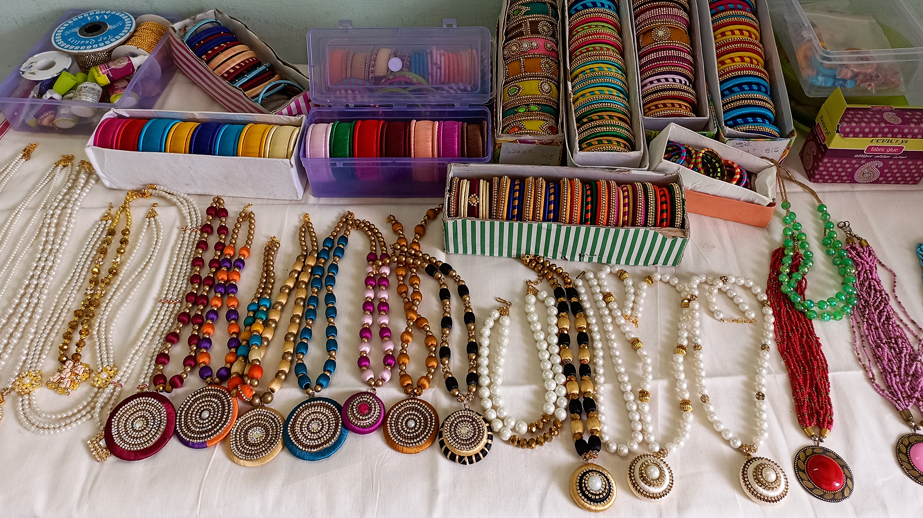
Artificial jewellery made by a Self Help Group member
Though they are excellent in product making and presentation, they are lacking in branding and marketing skills. So a common brand has to be created for these products and the women should get formal training to improve their marketing skills. Local women leaders have to be identified to optimally utilise the available community resources for their own betterment.

Village Name: Mookuperi Date: 16.08.2021
Block Name: Alwarthirunagari
Cluster: Handicraft
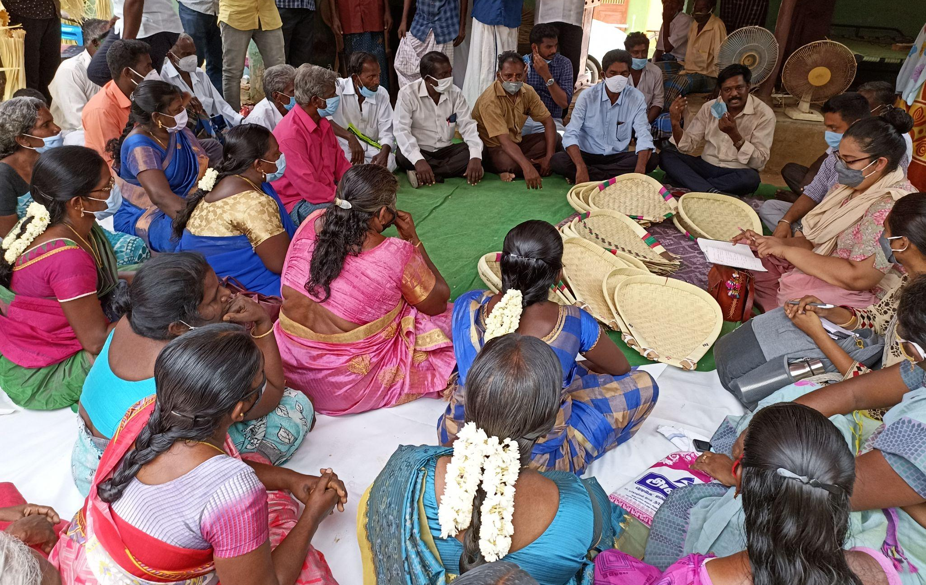
Mookuperi Community meeting
Mookuperi is a village where inhabitants are hereditary artisans who create an indigenous product called solagu (palm sieve). About 30 to 40 families are involved in this occupation for their livelihood. The entire process is done by hand without the use of any machinery. Both men and women share equal responsibilities in the creation of this product.
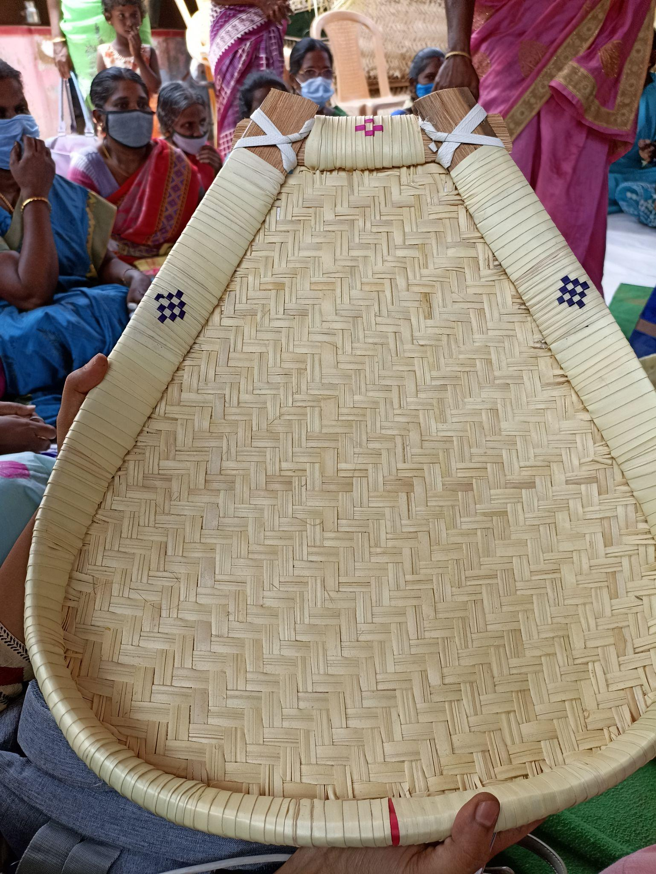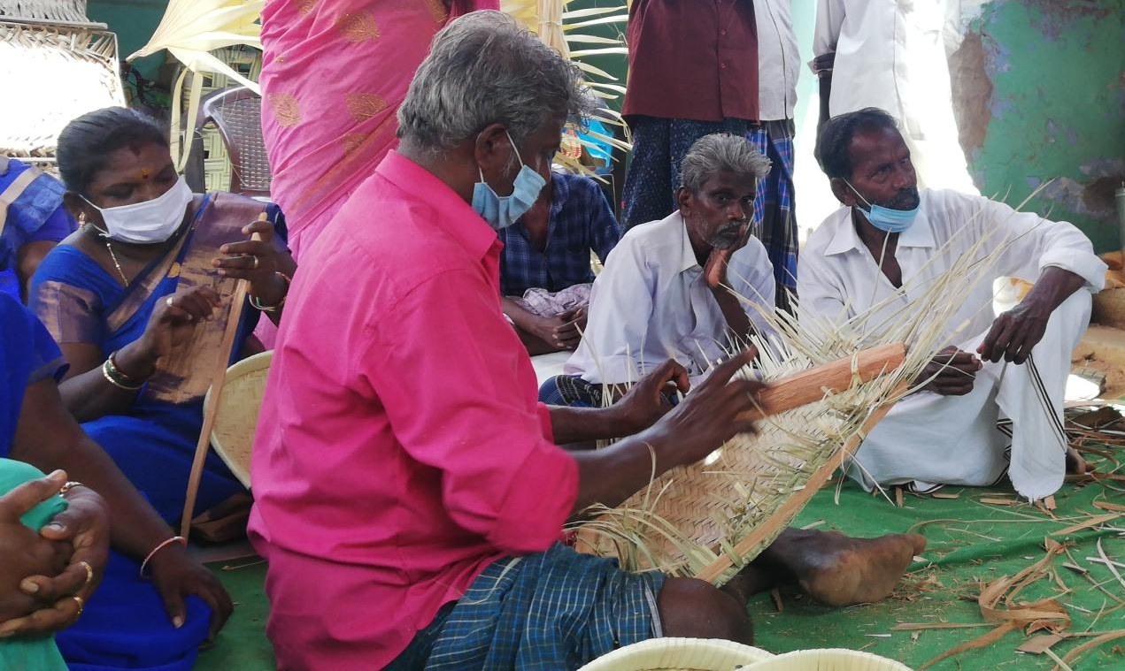
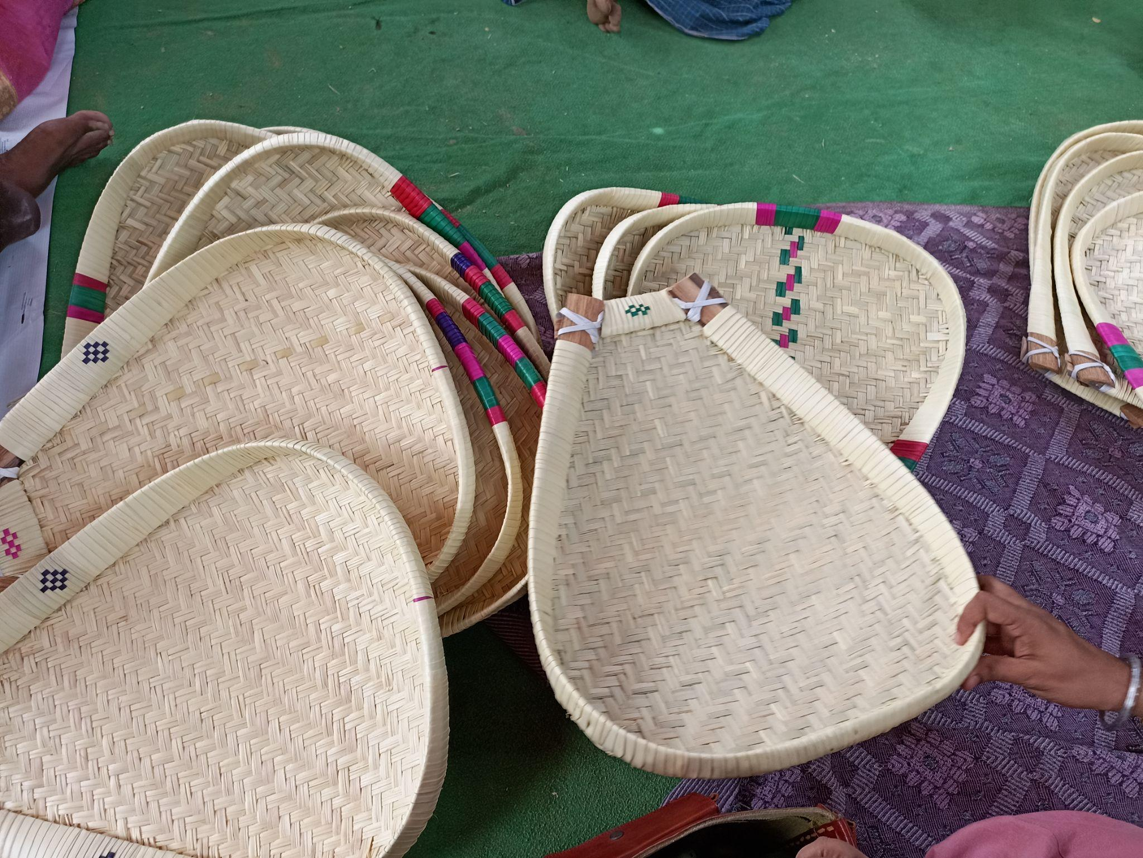
Palm Sieves (solagu) made by the Mookuperi community people
Traditionally they make these Palm sieves from two types of Palm leaves - Kurutholai and Pachaiyolai along with artificial color components. Men in the community purchase these raw materials from Thisaiyanvilai and a few places in Rameshwaram district. They spend around 15,000 rupees for its purchase. These raw materials are cleaned and dried by women. The men make the outer part with palm bark (pattai) and the women make the inner palm mat layer. It takes around 45 minutes to make one palm mat and two hours and 15 minutes to complete the whole product. The completed product will be taken by men for marketing; to be sold door to door. They also make palm boxes (kottans) with leftover palm leaves. They sell kurutholai sieves at a price of Rs. 150/- and the pachaiyolai sieves at Rs. 130/-. They don’t have any particular brand or market for their product.
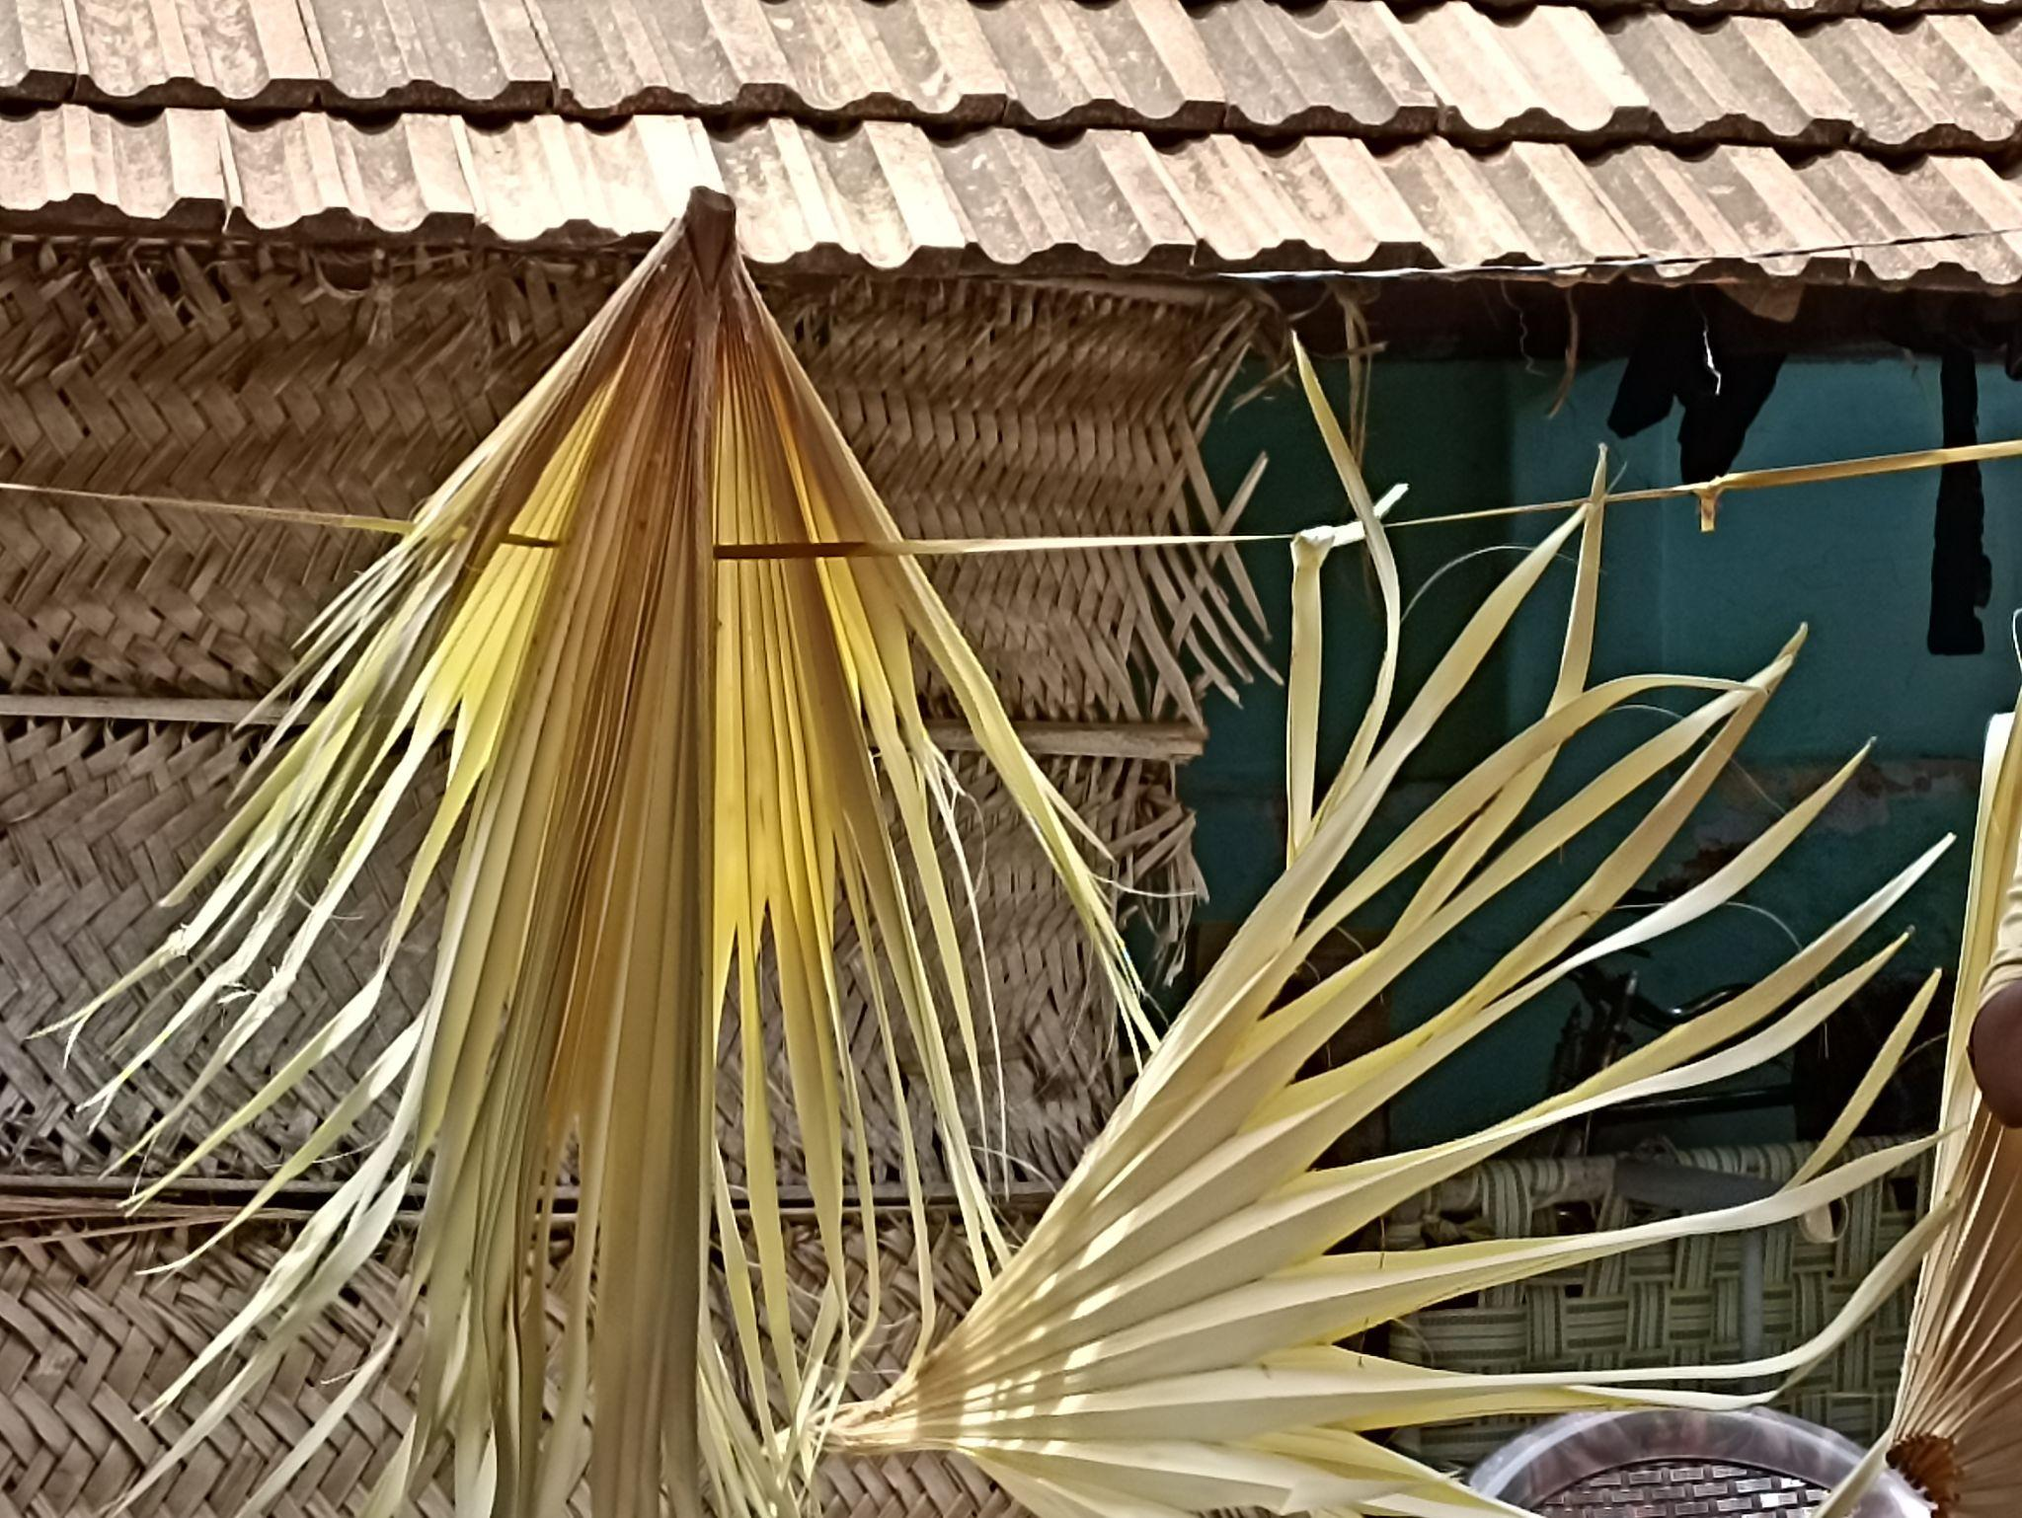
Palm leaves - Raw material of palm sieves

As narrated by the villagers, they borrow money from private money lenders to buy raw materials and they repay from their sales whether or not they make a profit. Close to 30 families are landless, do not have house pattas and live in rented houses. At times, they are refused houses for rent citing the nature of the craft that tends to generate waste in the process of creation. In olden days this product was used in the paddy harvest in the dehusking process. The advent of machinery in agriculture reduced the usage and value of these palm sieves. The community elders don’t want their next generation to continue this occupation, as a result of various stigmas that they are facing because of their occupation.
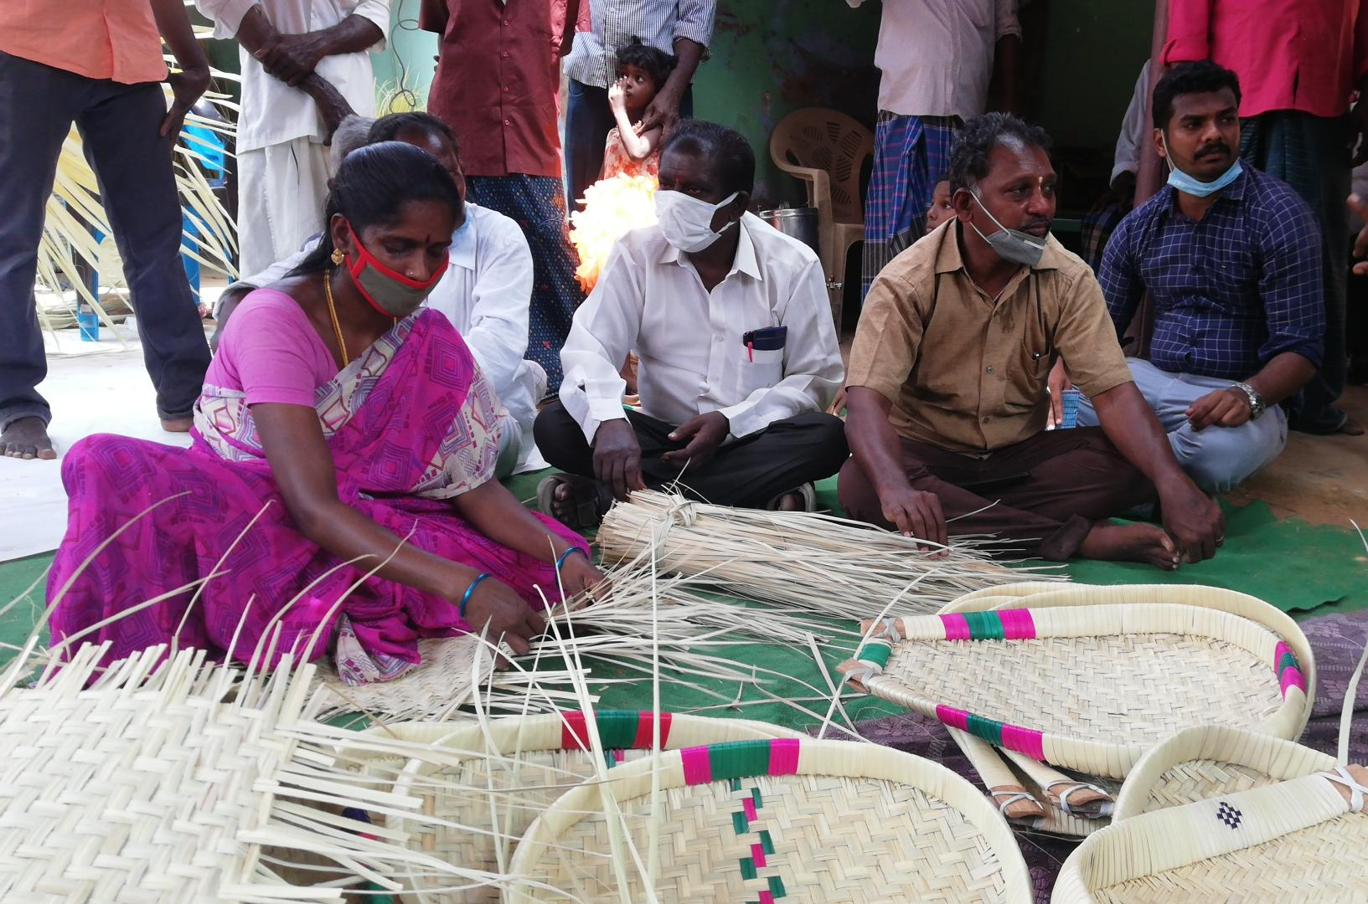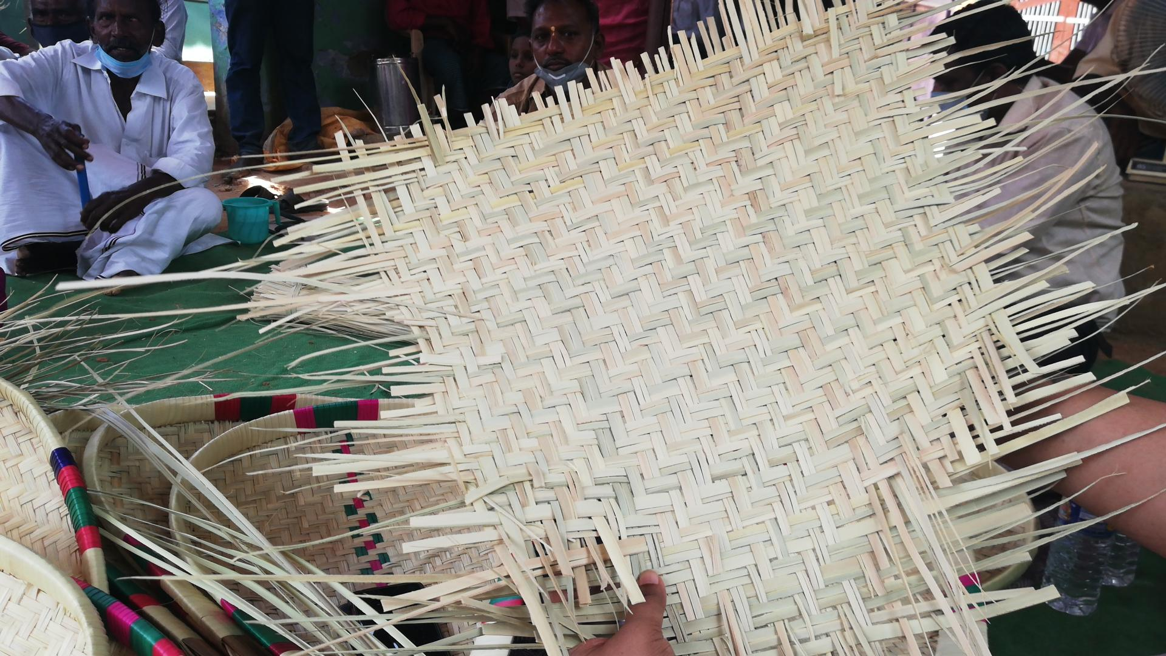
Women making palm sieves
Access should be provided for a proper workplace and raw material chain. Since they have inherent skills of making this product, the interested community youth have to be identified and trained to improve their marketing quality along with branding their product. Innovations in product development must be done with the participation of community stakeholders.

Village Name: Vettikulam hamlet of Serakulam village Date: 16.08.2021
Block Name: Karungulam
Cluster: Handicraft
Serakulam village is located barely a few kilometers from the historic archeological site of Thoothukudi district, Adhichanallur. The artisans belonging to the kullalar community have been living there for generations and their hands are skillful at making red and black pottery by using traditional methods. The indigenous people who reside in the river bank of Thamirabarani are solely reliant on the local geography for raw material supplies. Only eight families currently use this craft as the primary source of income. Kali mann (clay soil) from the Soriyandhur pond and kurumanal (river sediments) from Thamirabarani river bank at Karungulam are the two basic raw materials for this pottery making process. The villagers said that the police prevent them from collecting sedimentary soil from the river for a variety of reasons causing tremendous difficulties.
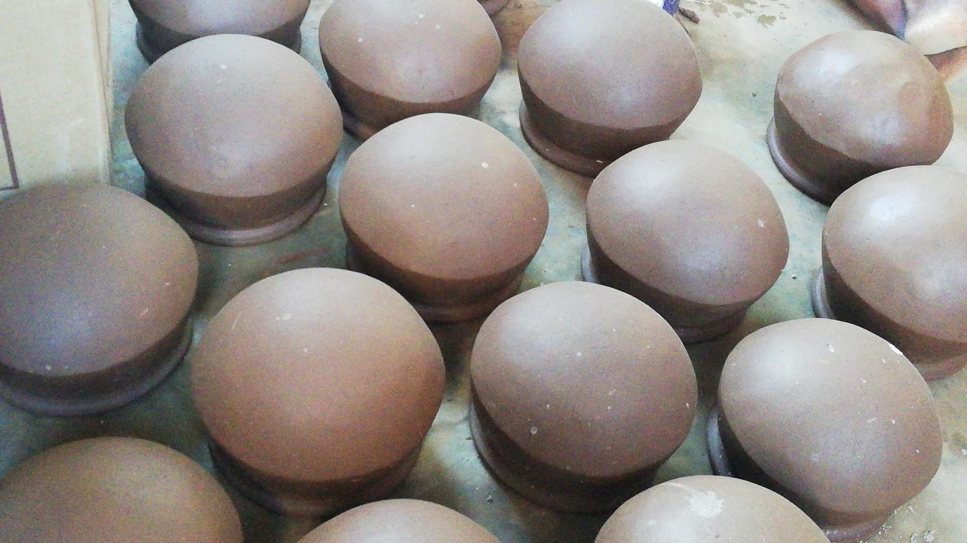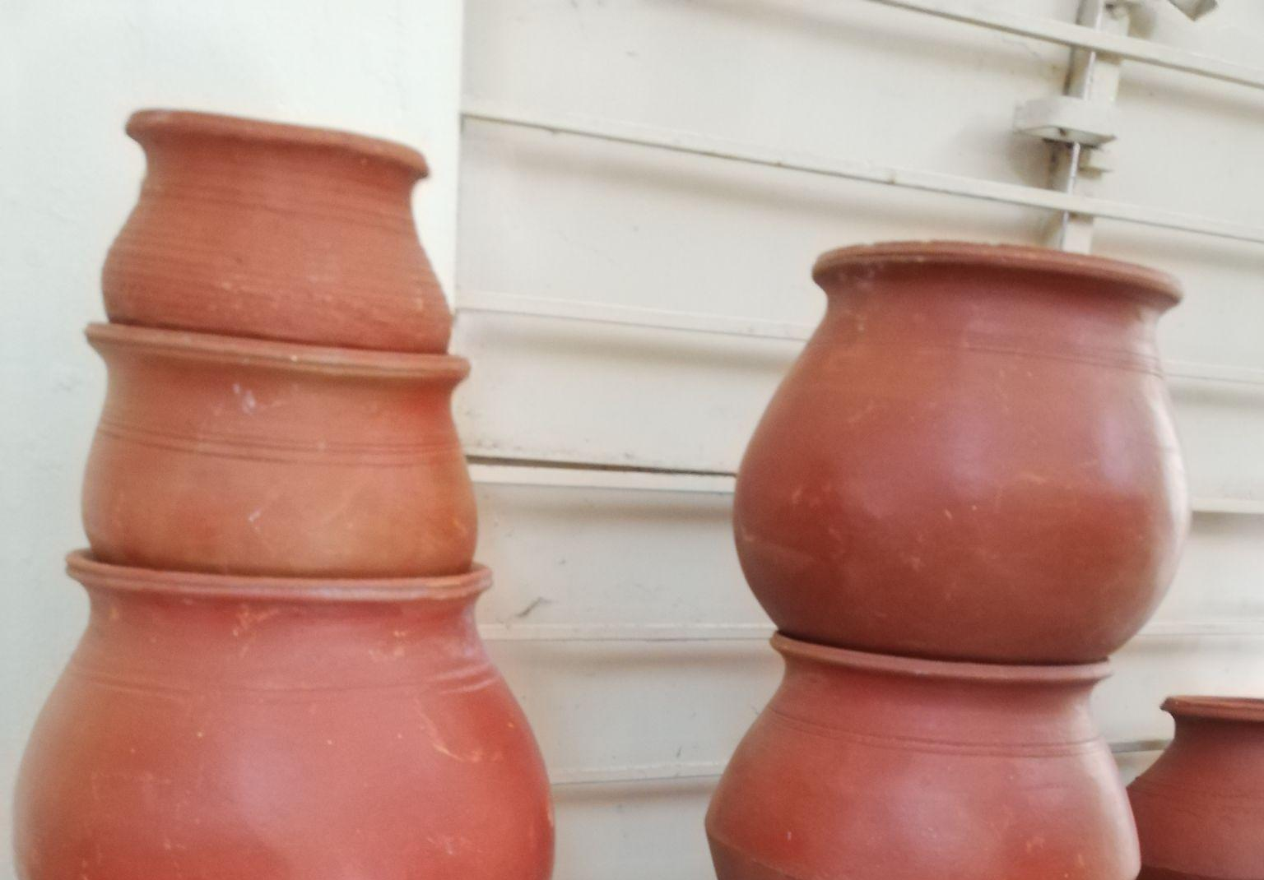
Red and Block pottery made by Vettikulam community people
Both men and women are involved in the product making process. The men collect the raw materials and smoothen the clay mixture along with women by stamping. Once the pots are given the basic shape, women artisans mould the finishing part of the pots by skillfully beating them with an array of soft sticks of various sizes, which needs utmost patience and concentration. Later they colour the pots with red bio colouring called Kaavi and dry them. They have a common furnace to burn pottery, where they do not do it individually, but collectively in specific timings. A new furnace worth Rs.1.5 lakhs was built for the cluster by the government under TNRTP.
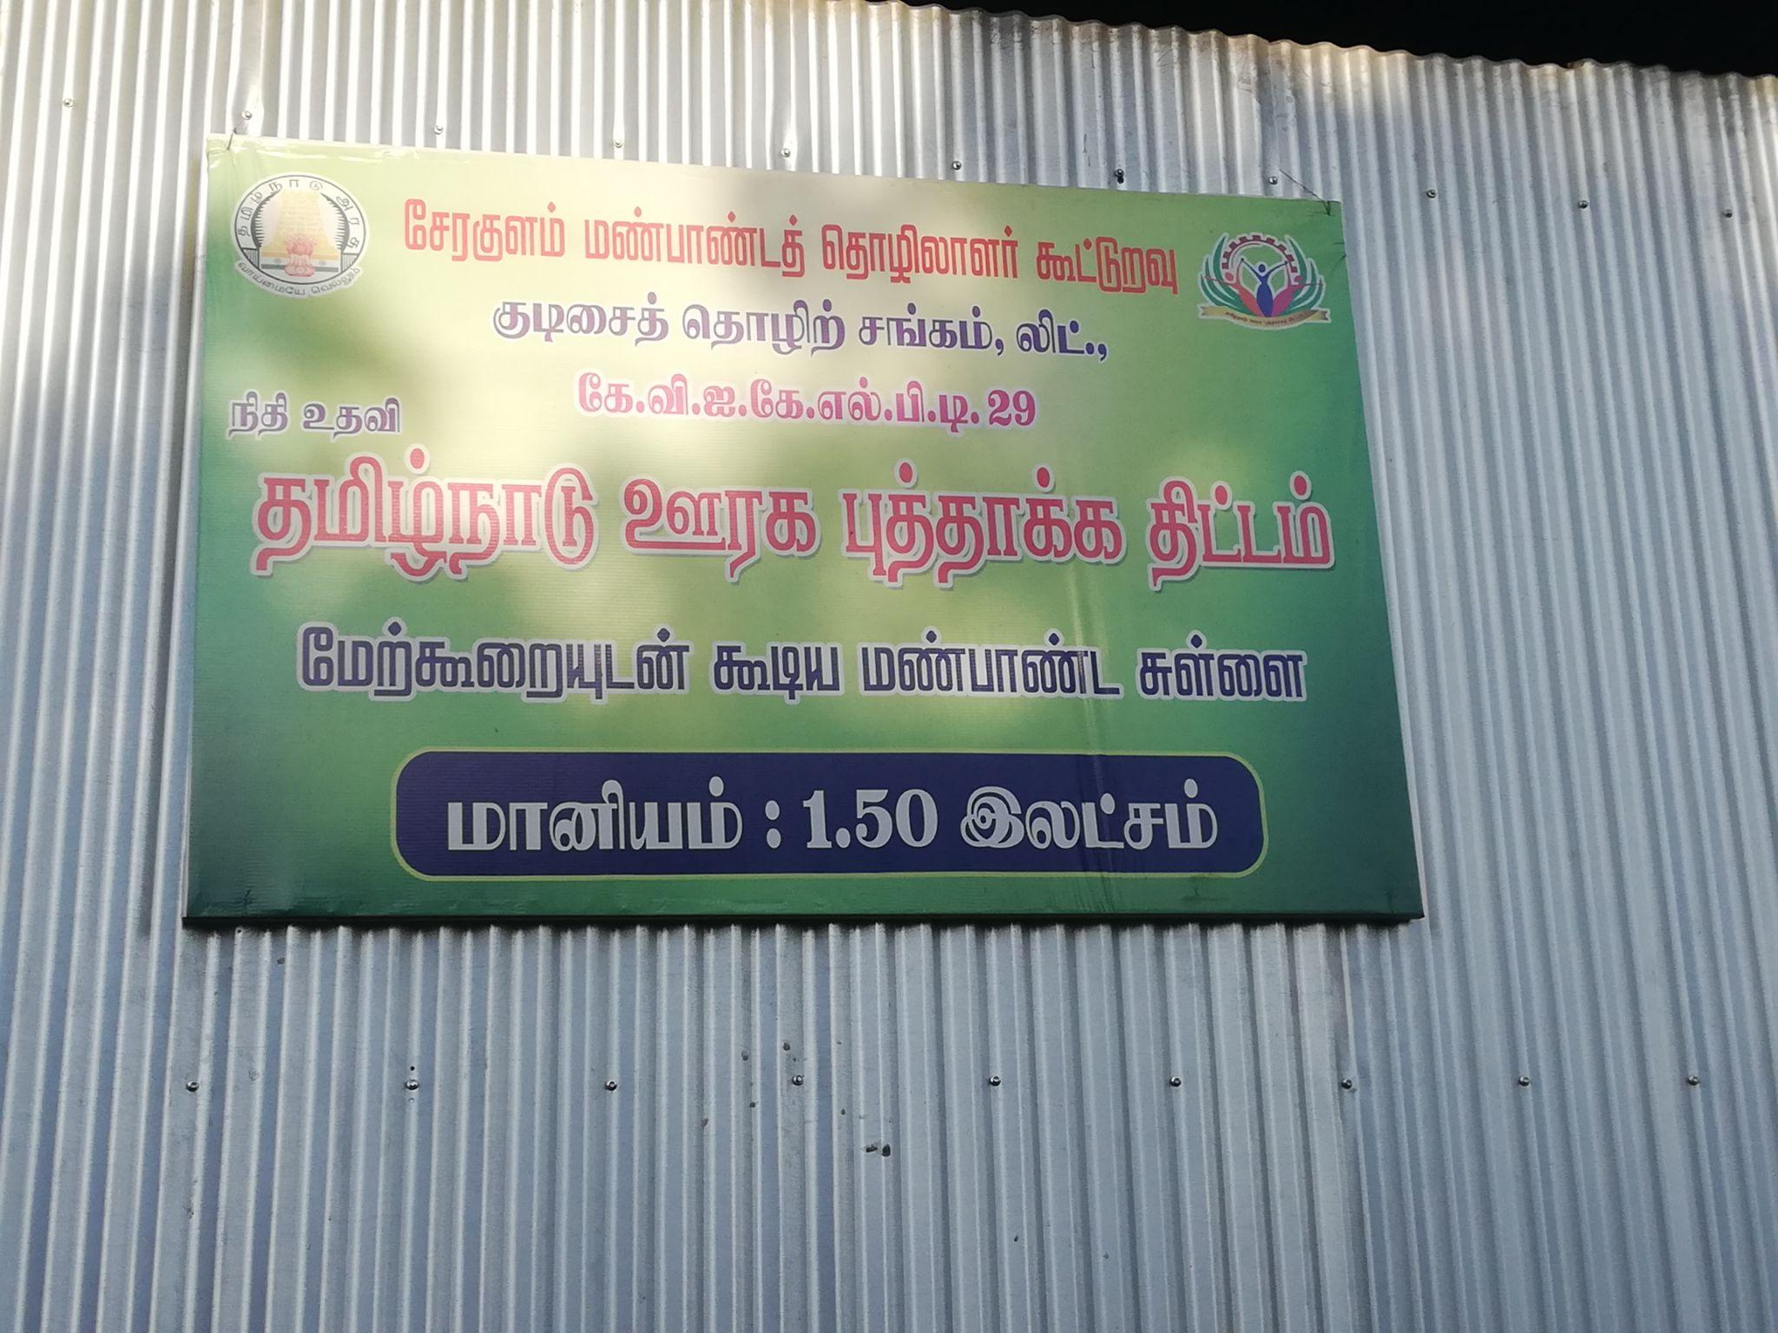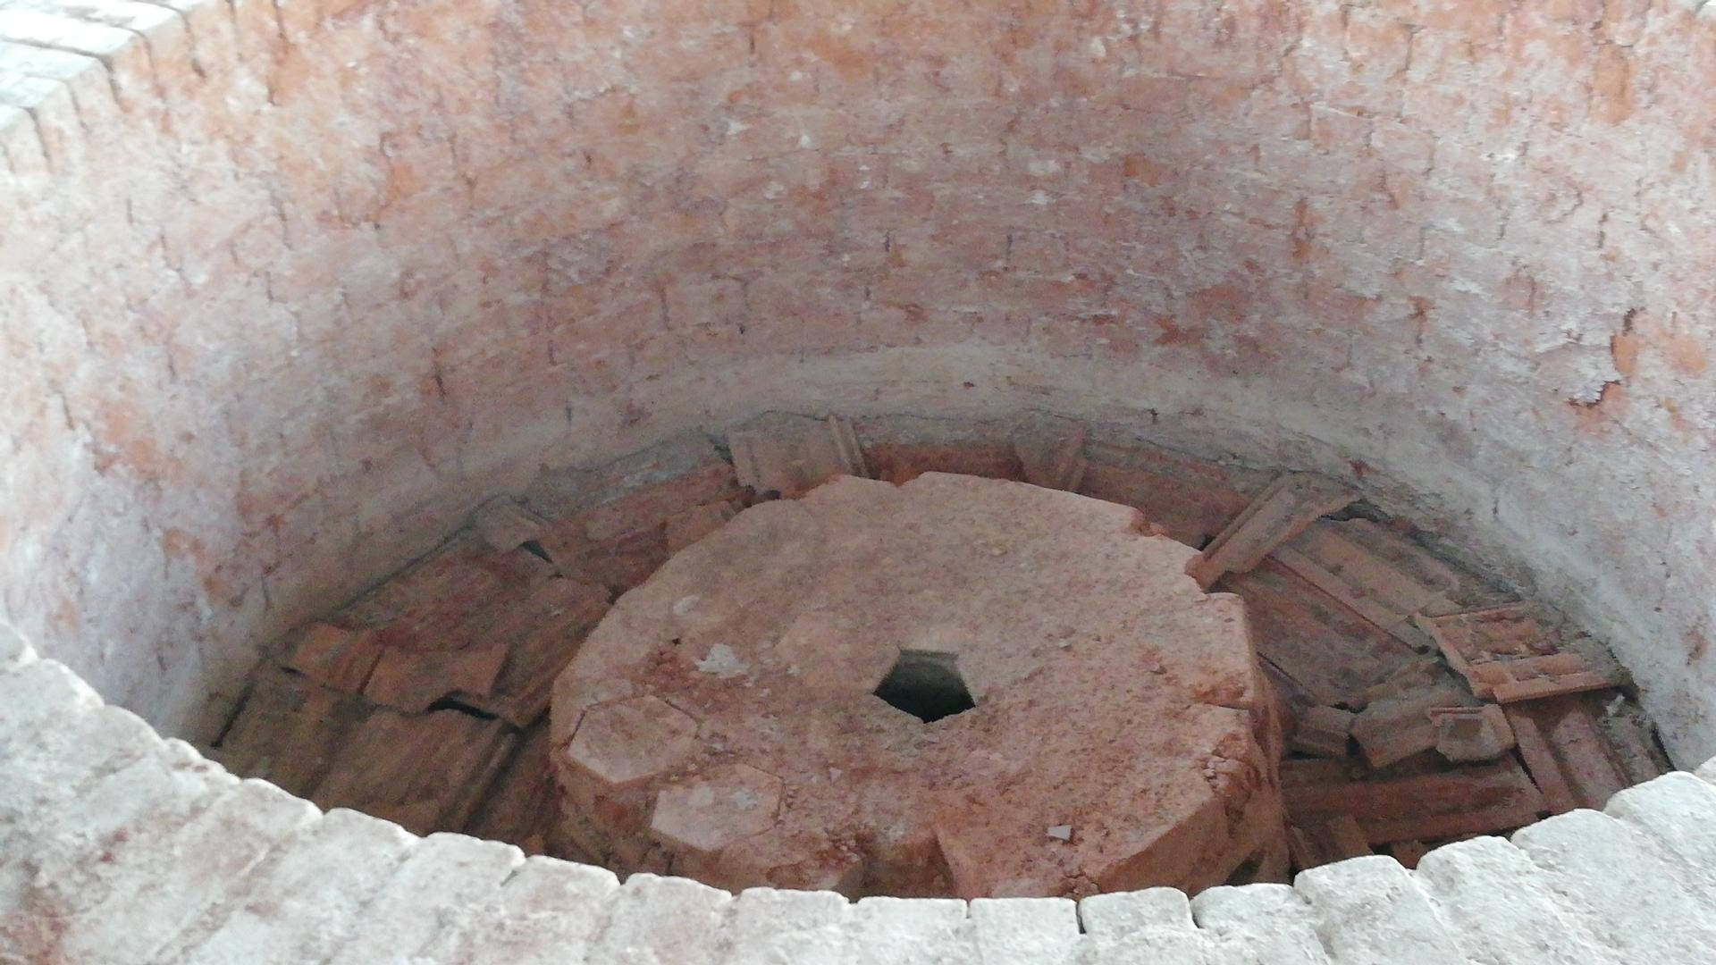
Furnace
The artisans sell their product to dealers who come from Keralat for a very minimum price. They sell big pots for Rs.20 and smaller ones for Rs.10, which is very low when compared to the actual market price of Rs. 150 and Rs. 200.
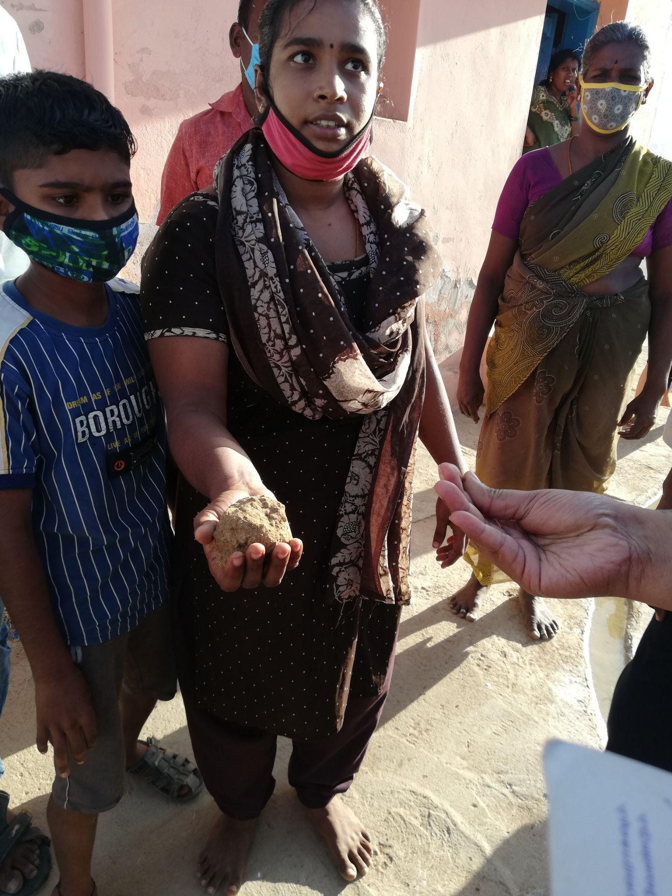
Community woman Aruna showing us the soil that they use for pottery making
Most of these artisans are landless and assetless whose rights have been denied for generations because of various social constraints. The artisans need access to physical or digital market space. Proper branding and marketing training must be provided to the people by experts. Local markets have to be identified. Young women leaders have to be identified and they should collectivise the community to address their issues.
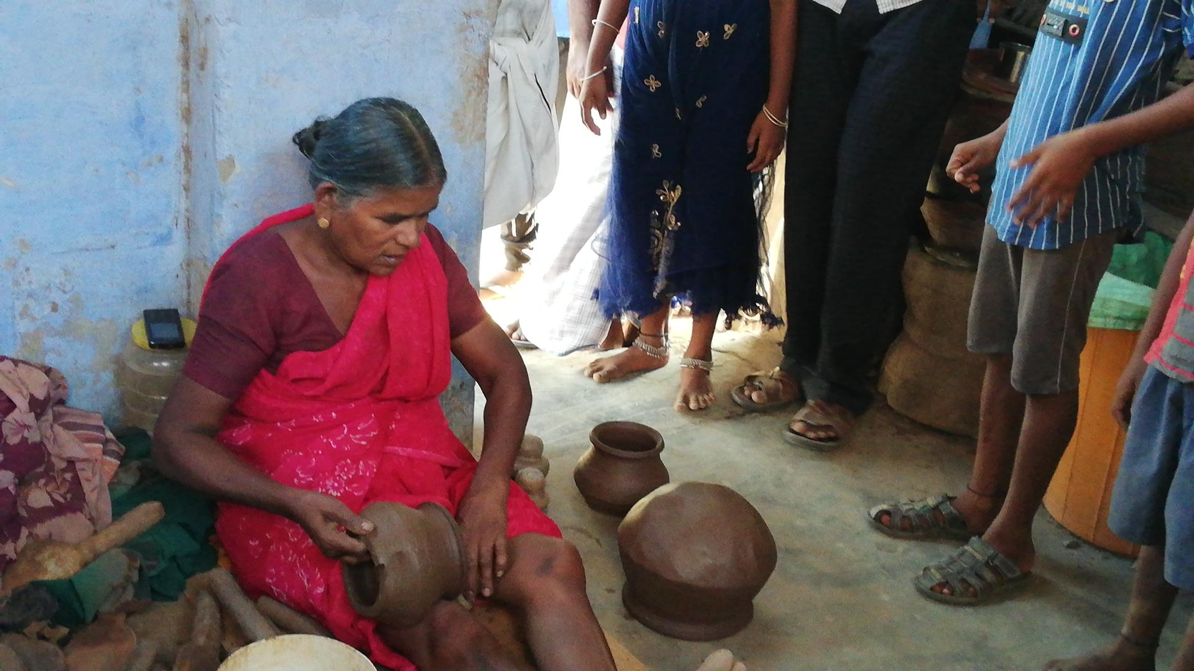
Women making pottery
Handmade pottery is an endangered craftform, the living artisans don't want to pass this unique skill to their younger generation, since they believe there is less hope for development.

Cluster: Handicraft
Institution: WEEDS organization Date: 16.08.2021
Village: Mudhalur
Block: Sathankulam
Cluster: Agriculture
The women SHGs from Mudhalur Panchayat are collaboratively working with an NGO called WEEDS (Women Education and Employment Society) under TNRTP to produce Moringa Honey. There are 400 women involved in this process and they have placed 2000 bee boxes in the nearby farms to collect honey. Since 2014, NABARD has been helping these women to get training in producing Moringa honey. It is a seasonal occupation where they can produce honey for 7 months a year from April to October. They get around Rs.35000/10 acre per year as profit. They have named their collective ‘Vidiyal’ and the brand name of their product is ‘Saral Then’.
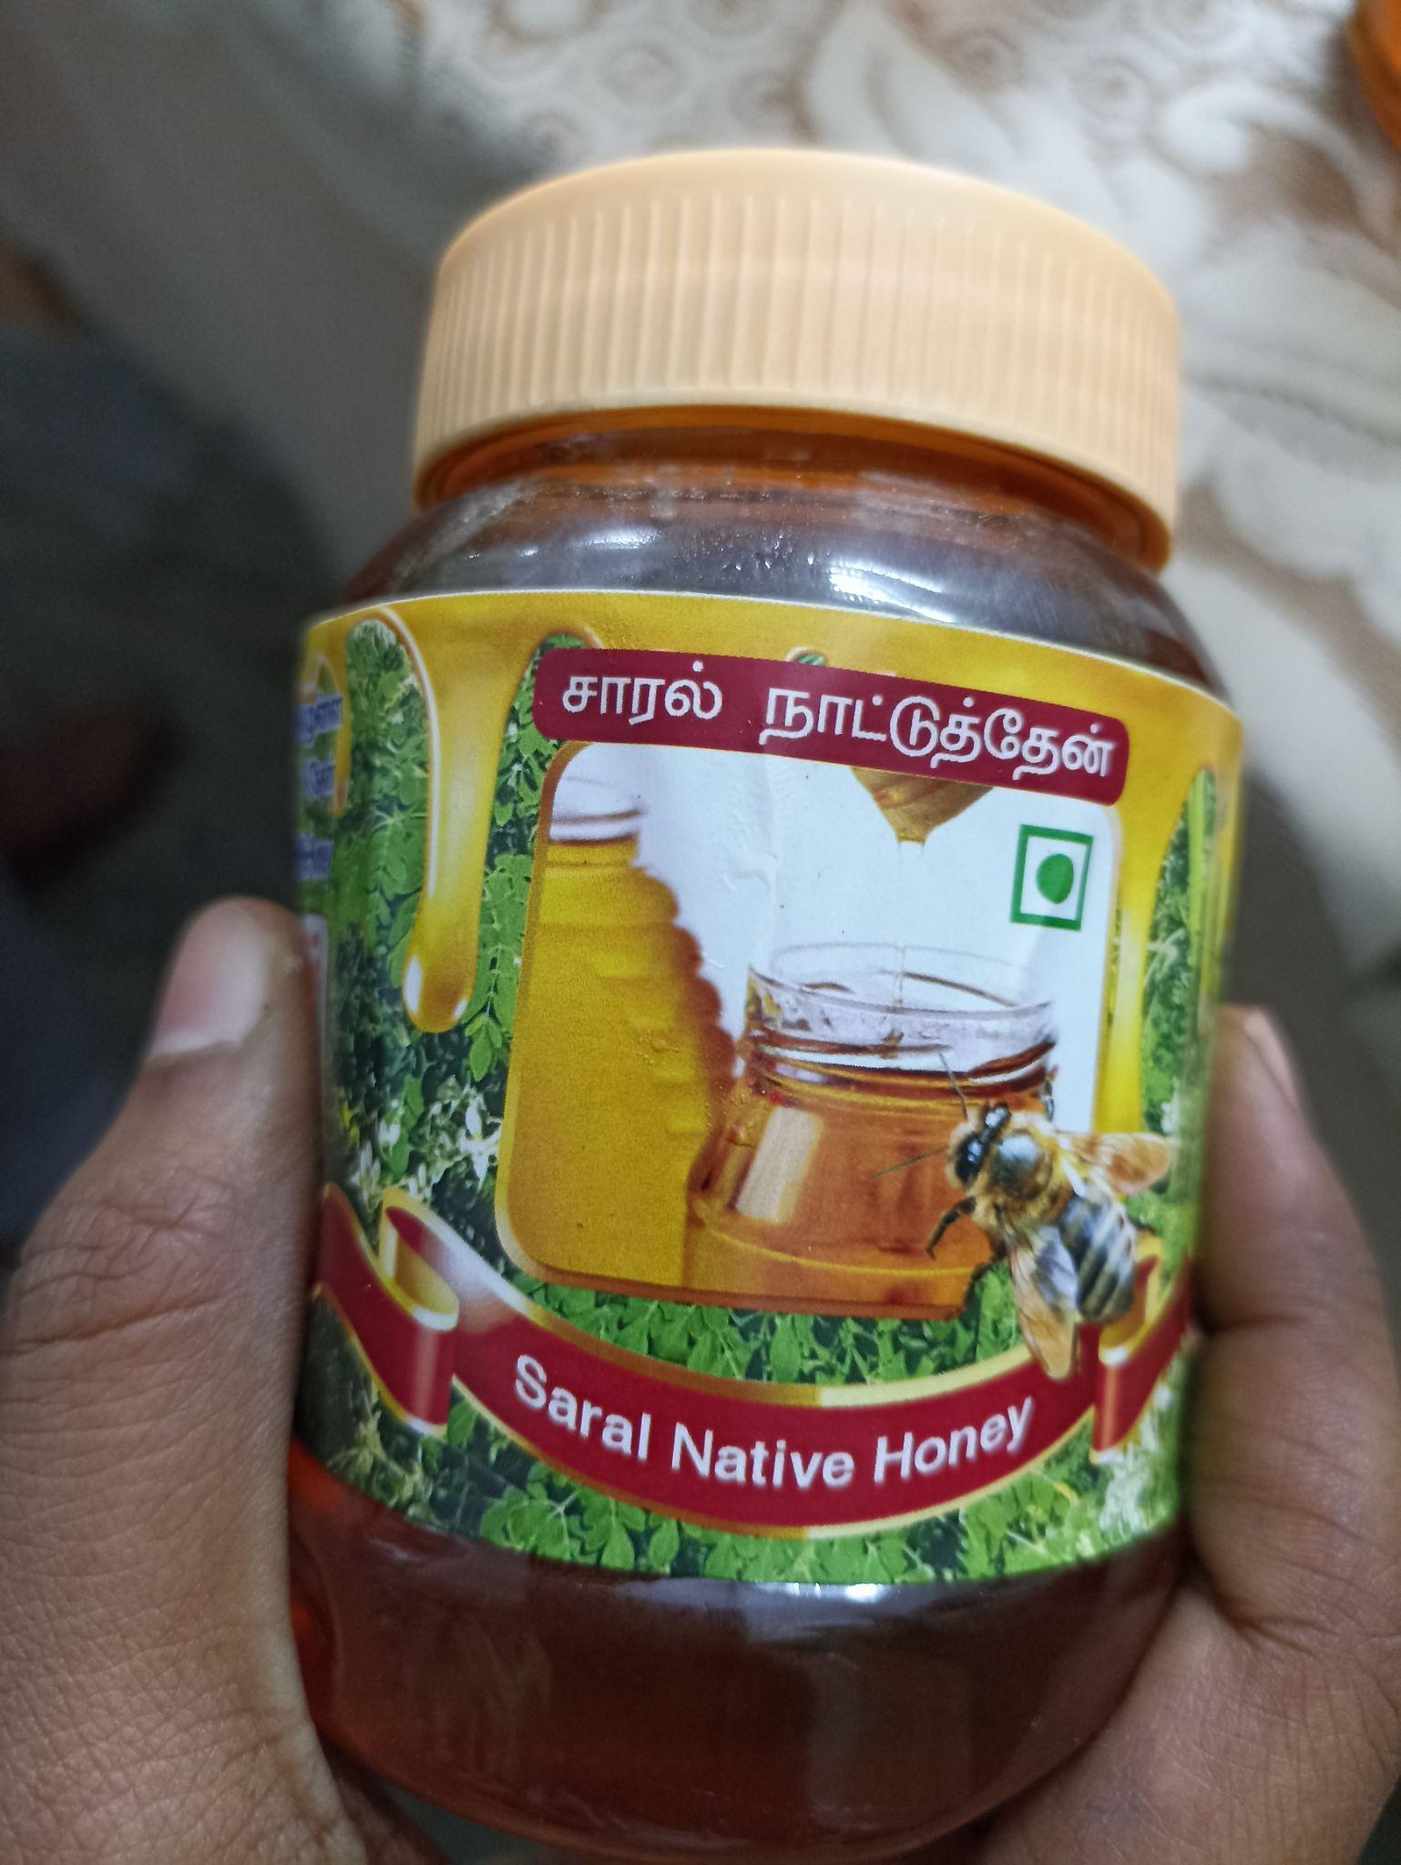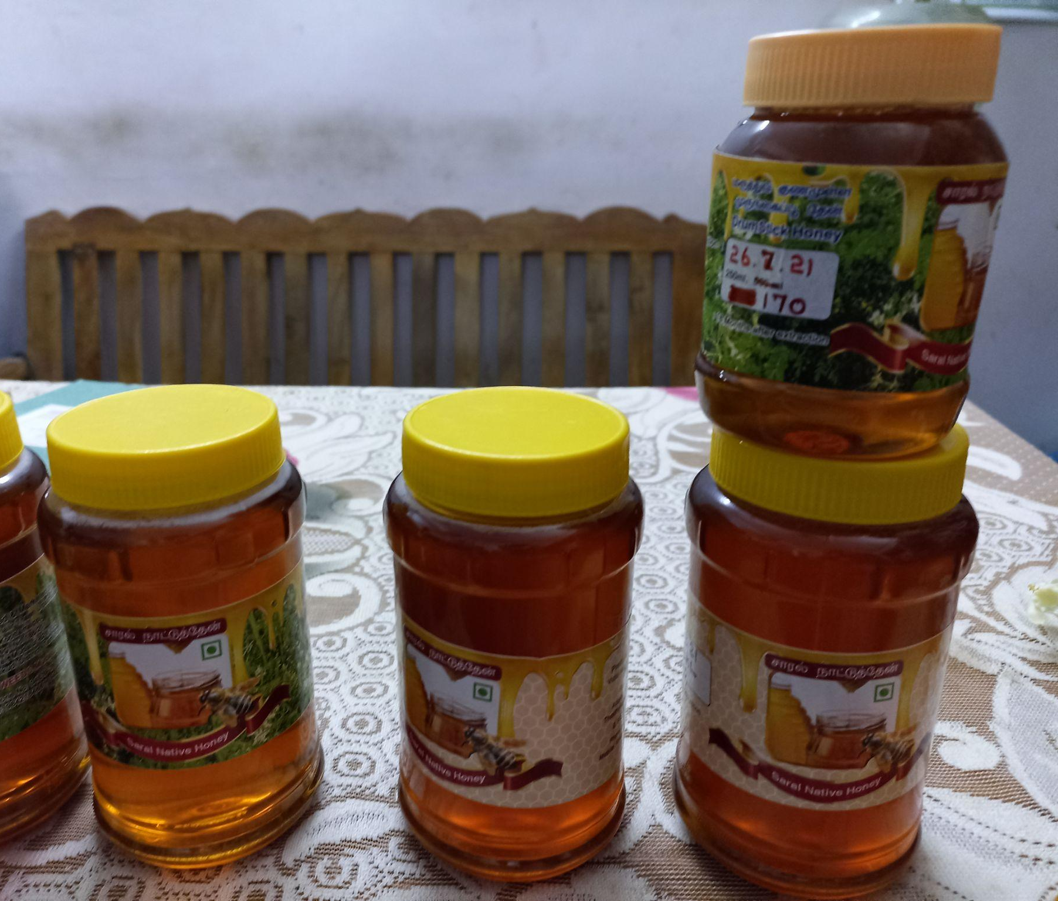
Moringa Honey made by SHG women of Sathankulam block
As the SHG women said, most of them are landless. So, they have to give 1 liter of honey to the landowners where they keep their bee boxes every time they collect honey. Women in the group are keen on collectively getting access to some land, so that they can work and place their bee boxes without having to pay someone else for it as well as expand the scope of their business.
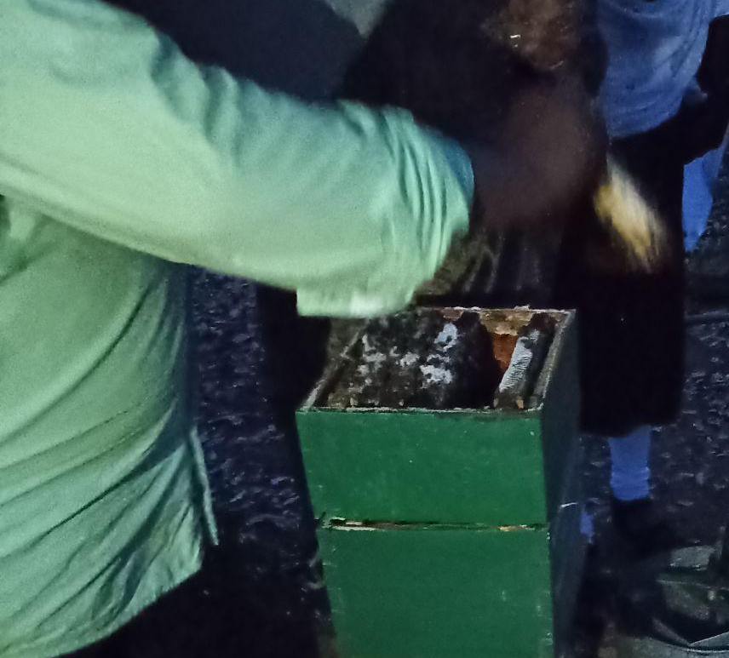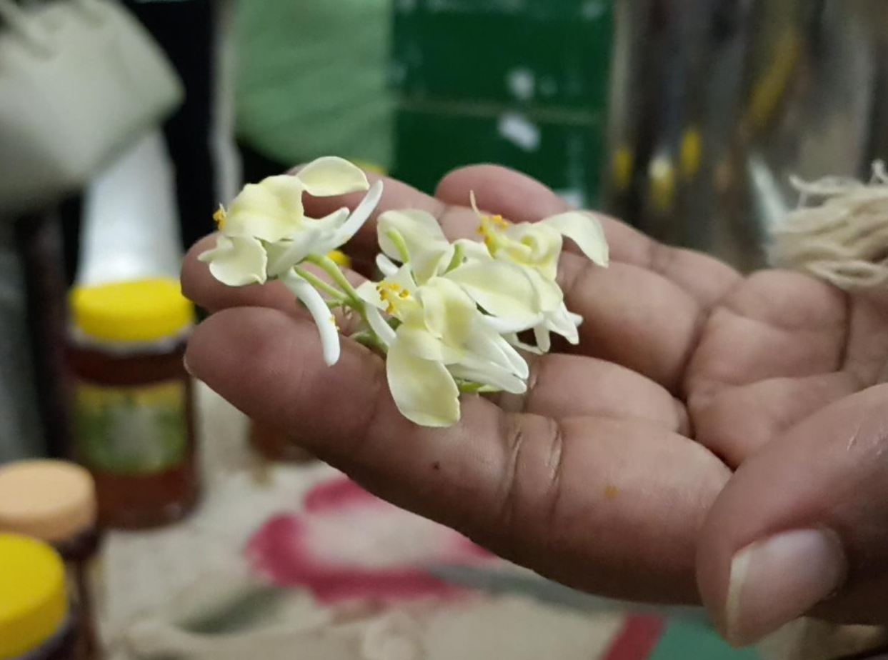
Honey hives Moringa flower
The group is interested in making all the by-products of Moringa by collective cultivation of Moringa trees. They are also planning to cultivate profitable agricultural produce by intercropping among the moringa trees to generate additional income.

Date | Village Name | Block | Cluster
18.08.2021 | Nagalapuram | Vilathikulam | Handicraft
18.08.2021 | Ariyanayagipuram | Karungulam | Agriculture
18.08.2021 | Thappathi | Ettayapuram | Fisheries
In Nagalapuram village, the community has been making palm boxes for generations. Majority of them are landless and assetless. There are seventy families making these palm boxes for their livelihood. Each person can make approximately 200 palm boxes per day. Two families from the community procure raw material for the whole community and they pay them Rs. 30/- for making 100 boxes. They sell this palm box for Rs. 4/- each to the dealers. Every month they sell 10,000 boxes to a dealer from Sattur, Virudhunagar district. From this they are getting Rs. 40,000/- which is the only regular income that they are earning from this product for all these 70 families. This production cycle involves both men and women. Apart from this, they are dependent solely on the MGNREGA for their source of livelihood.
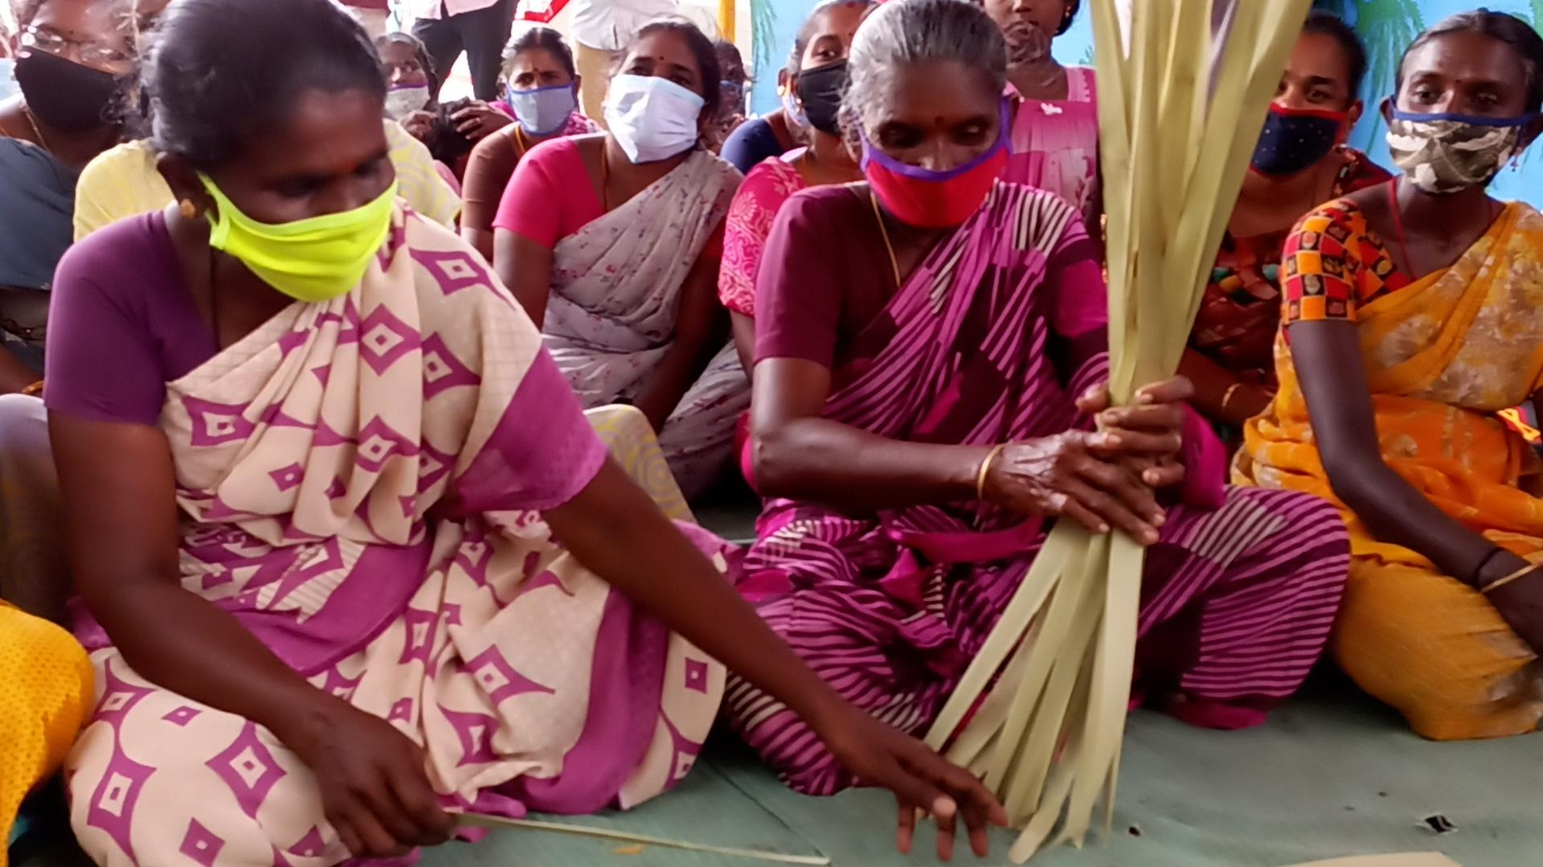
Nagalapuram community women making palm boxes
They are indeginous people of that land and their hands have the skill to make these palm products at lightning speed, but they have less access to the market and branding for their product. These palm boxes can be used as an alternative for plastic covers to pack goods which are also biodegradable and can be used as ‘use and throw’ boxes for packing food products.
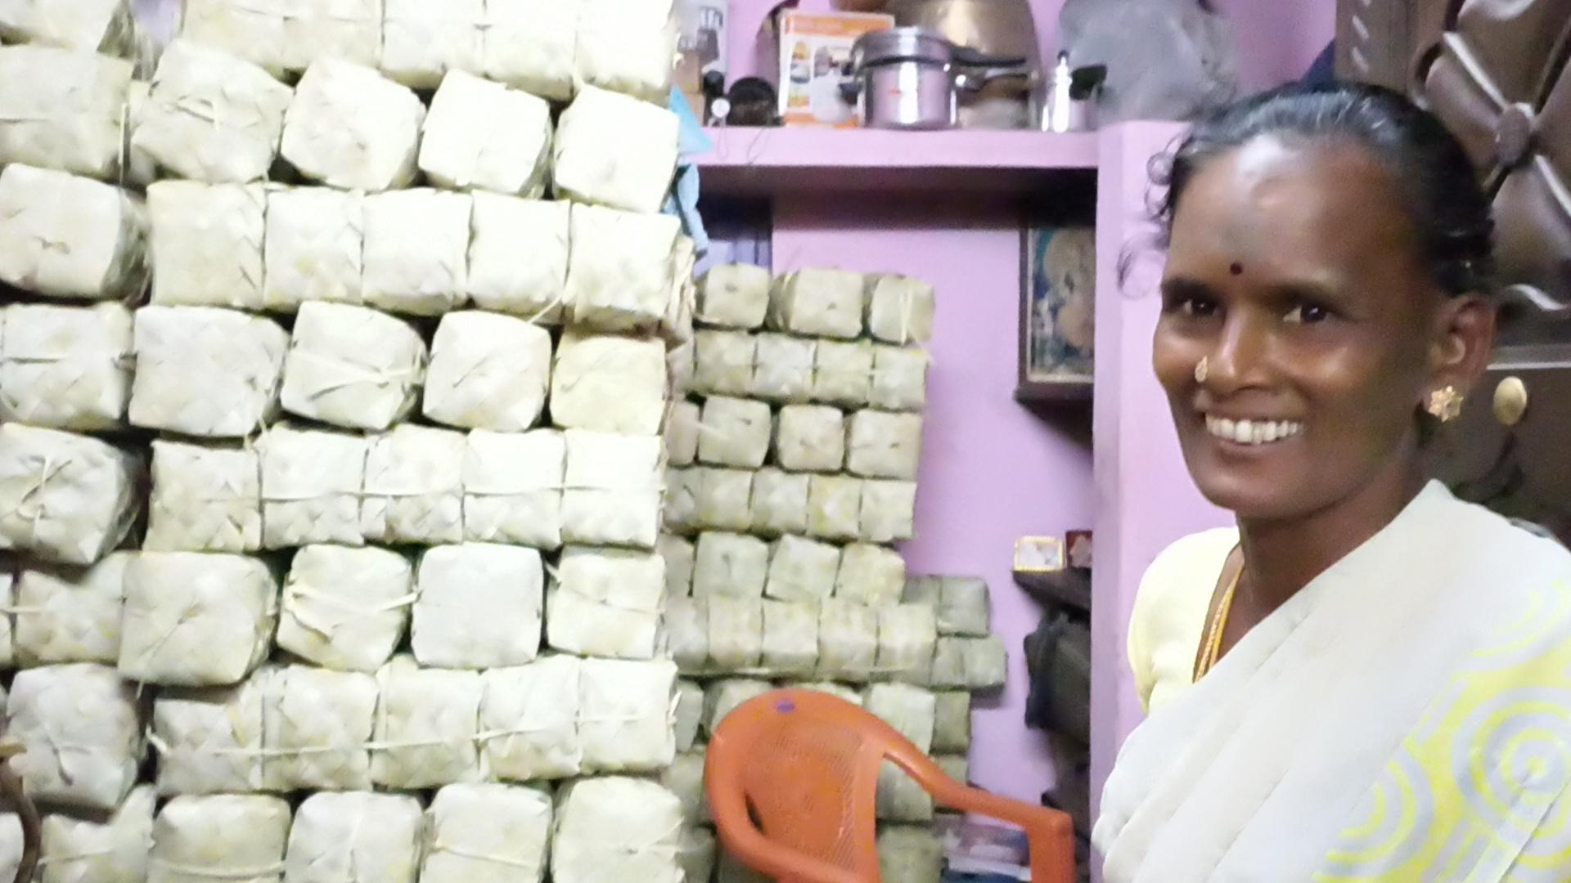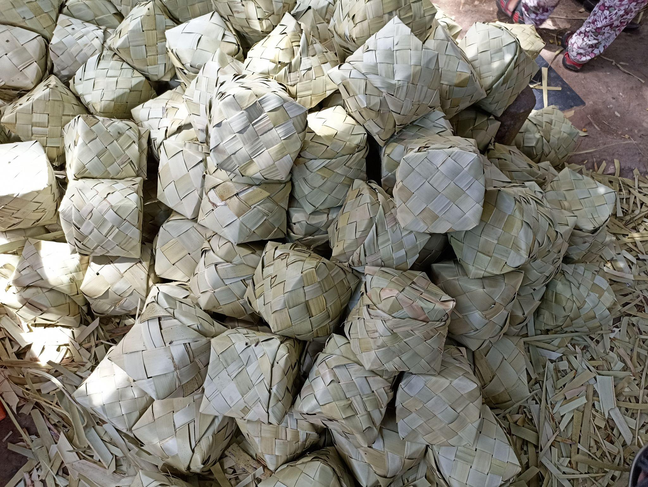
Palm boxes made by Nagalapuram community people
In Nagalapuram, the team met with the SHG women under Mahalir Thittam from Thappathi refugee camp of Ettayapuram block and Ranganayagi puram village of Karungulam block. The Thappathi refugee camp women are making artificial jewellery under Mahalir Thittam. They do not have a regular market to sell these products and also they need access to a regular work space for this product making along with a space to run a stitching unit.
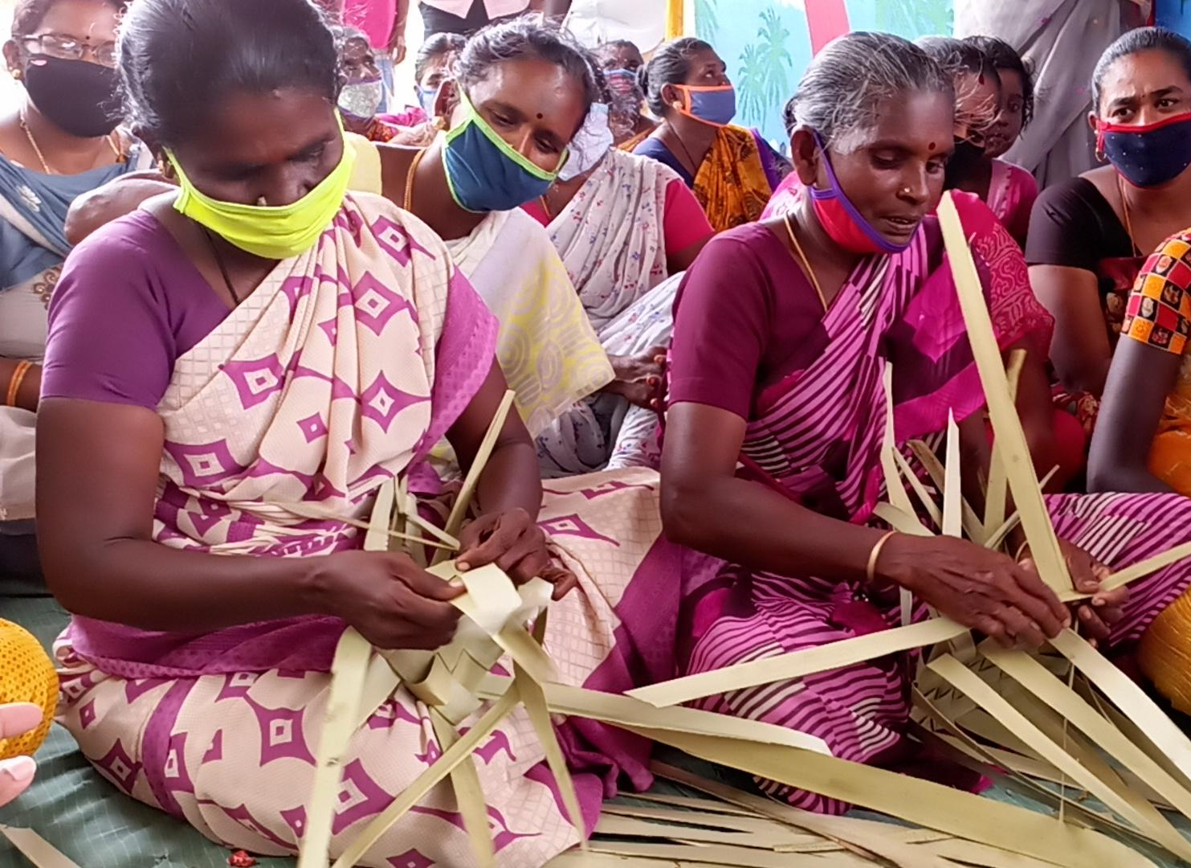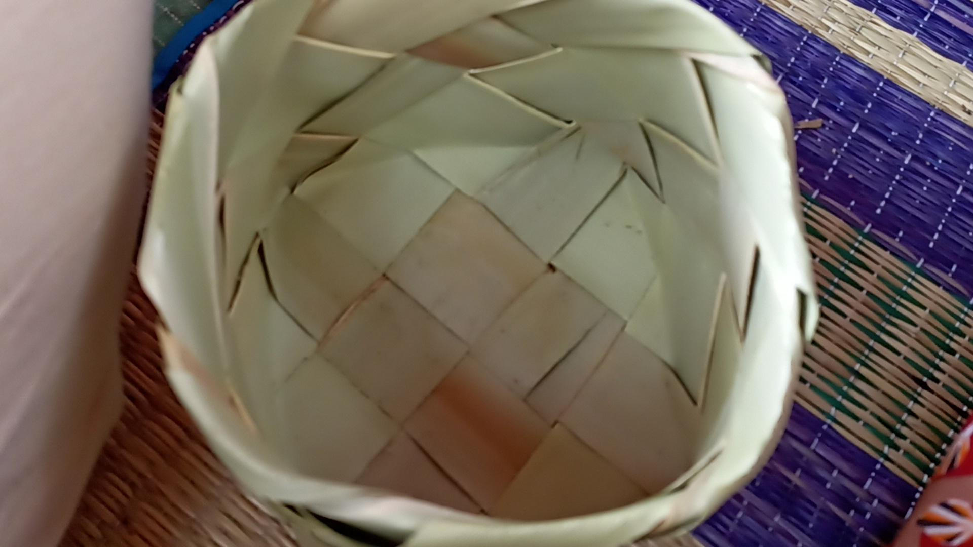
Palm boxes made by Nagalapuram community women

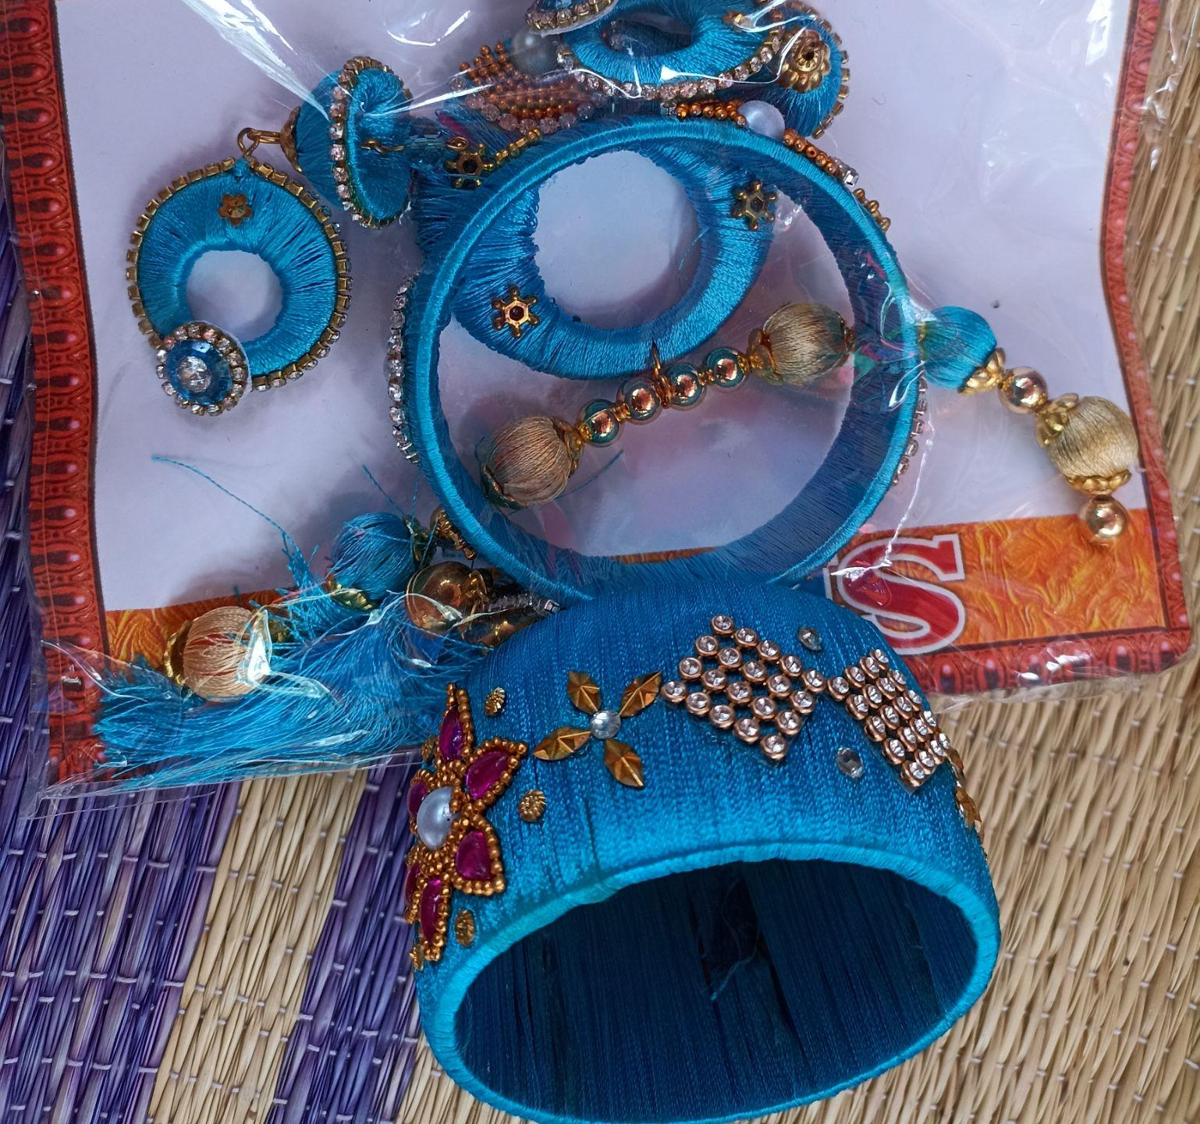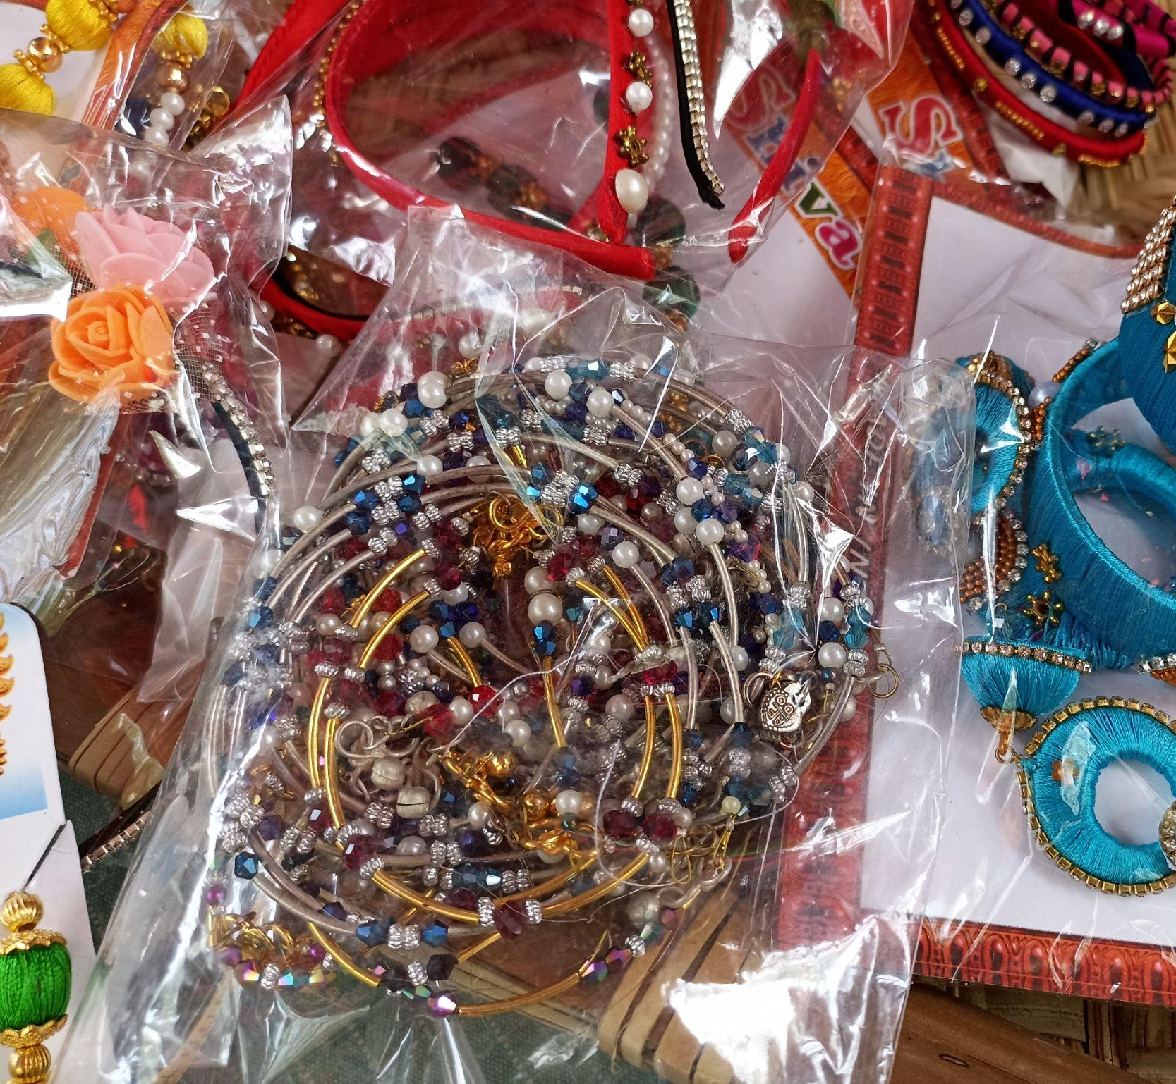
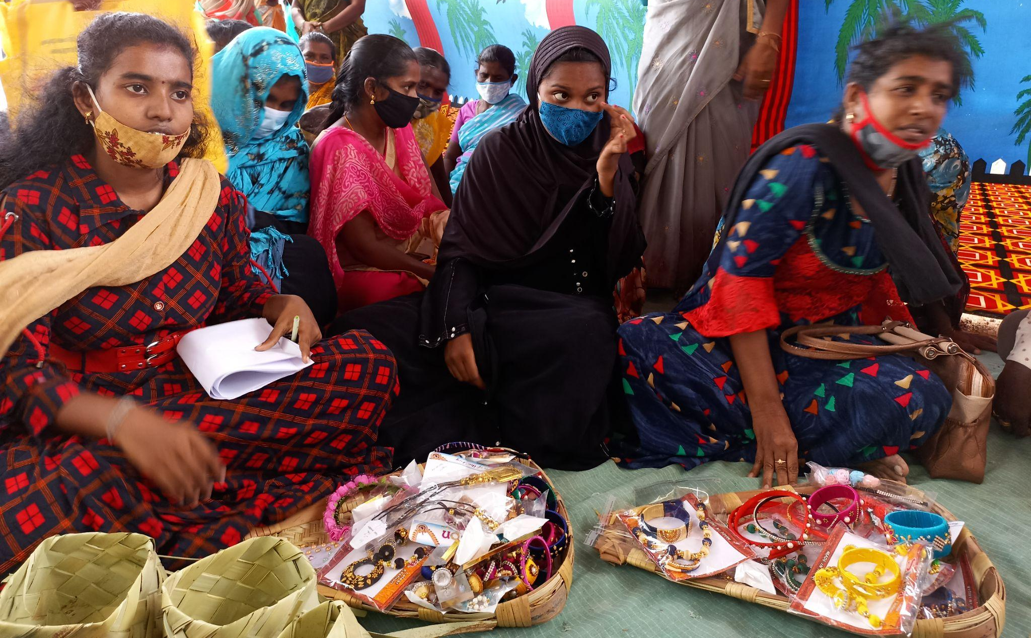Artificial Jewellery made by women from Thappathi Refugee camp
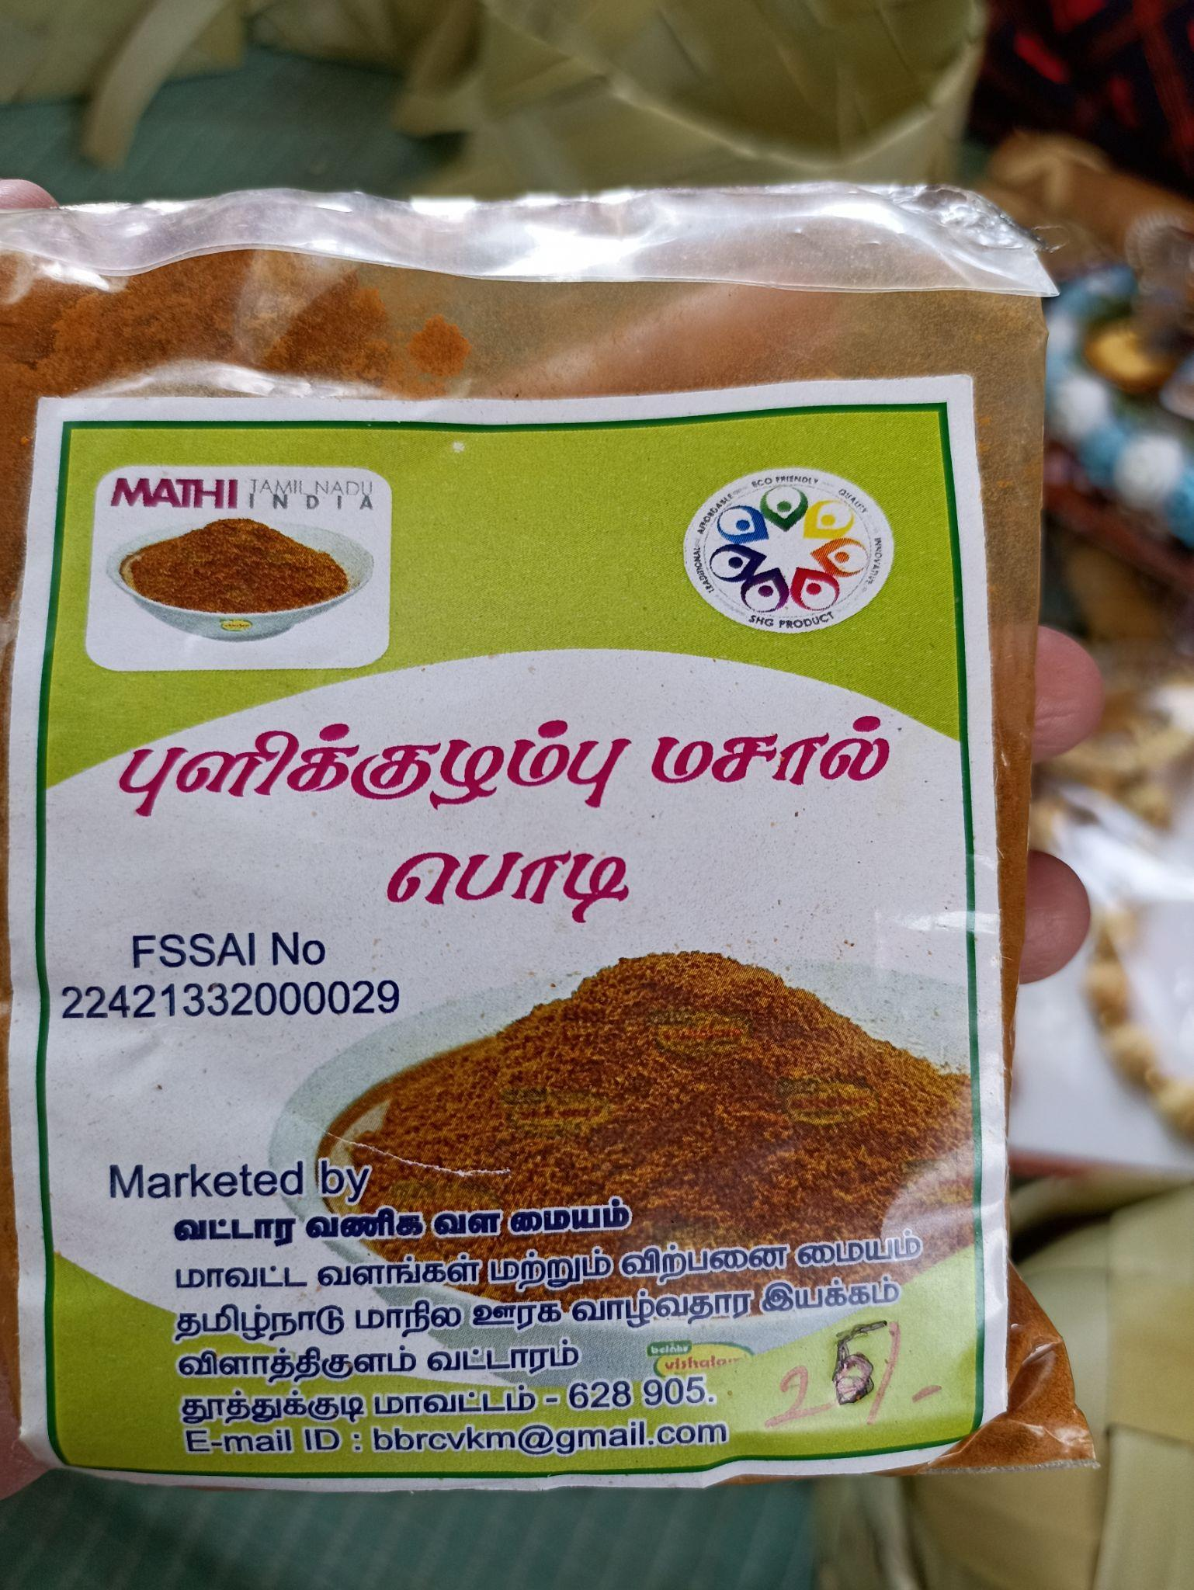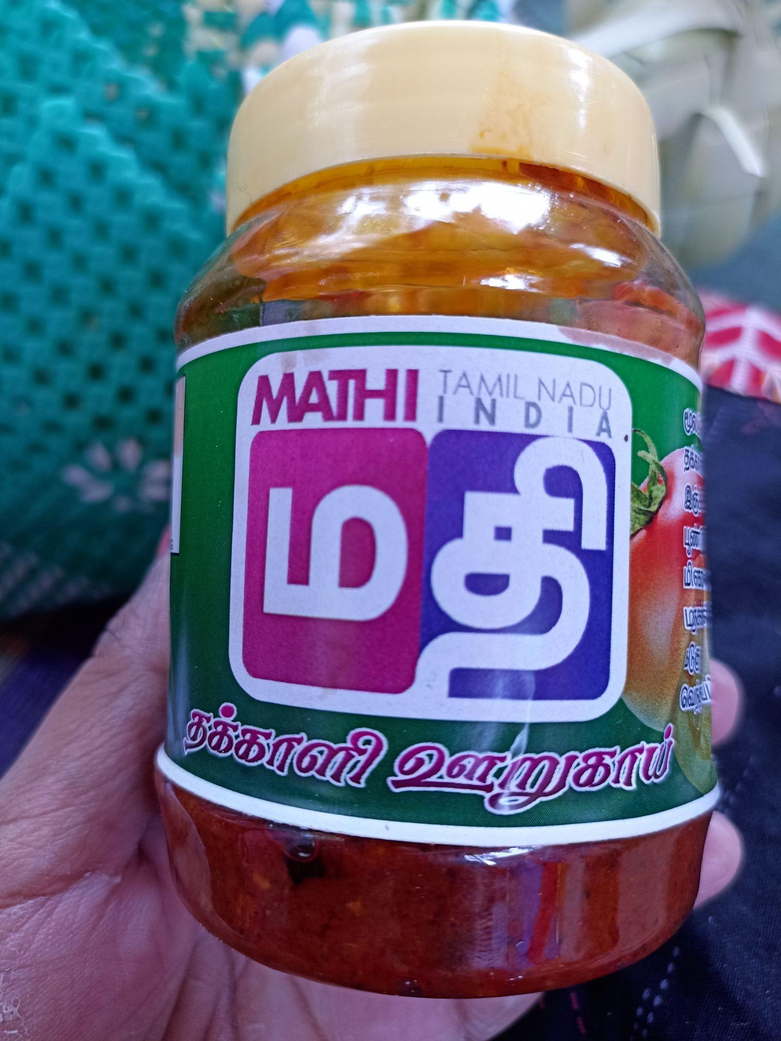
Powdered spice and Tomato pickle made by
Ariyanayagipuram SHG women under Mahalir Thittam
The women from Ariyanagaipuram make food products like powdered spices and pickles and sell it under the brand name of Ma Thi (Mahalir Thittam). Unlike other clusters they have a logo for these Ma Thi products. They sell their products in Pasumai Angadis and to individuals on demand basis. They talked about the millets that are being cultivated in their surroundings and that they were thinking of new food products which can be made out of those crops. A woman from that SHG is also making foot mats from rags. She is self-taught and learnt this skill by watching YouTube videos.
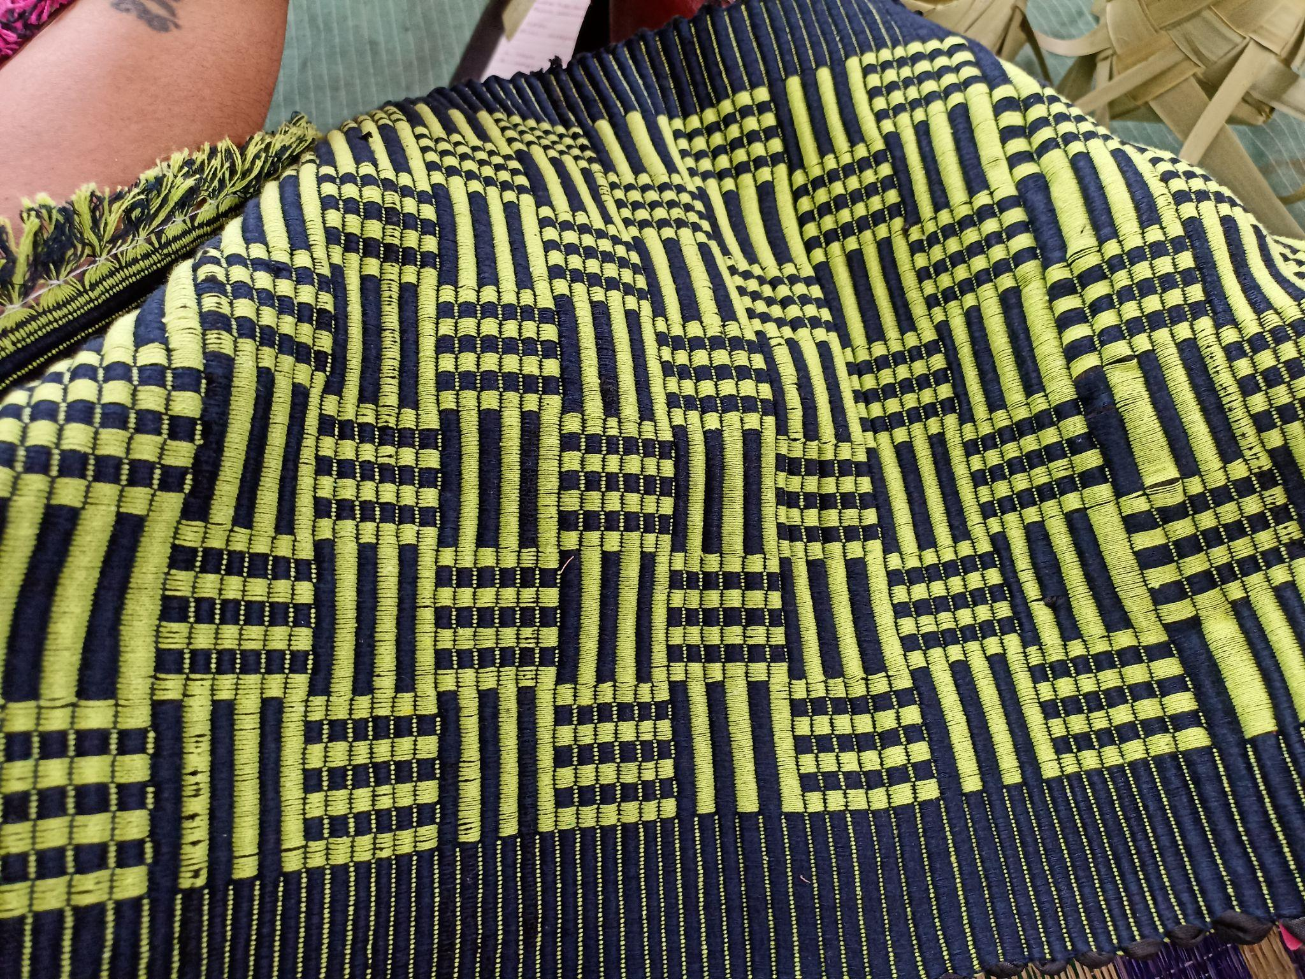
Foot mat made by a woman from Ariyanayagipuram village

The women have the ability to make these products, but at some point they need to be equipped with branding and marketing skills. Unlike other clusters, they have a brand name and logo but there is no space for them to take ownership in the marketing.
Village Name : Thalamuthu Nagar Date: 19.08.2021
Block: Thoothukudi
Cluster: Fisheries
In Thalamuthu Nagar, our team along with the officials from the Department of Fisheries visited a private small-scale company where sea shells are cleaned and processed. 90 percent of the employees working here are women. A few years back the women were also involved in seashell ornament making, however now that has come to a halt due to lack of market access.
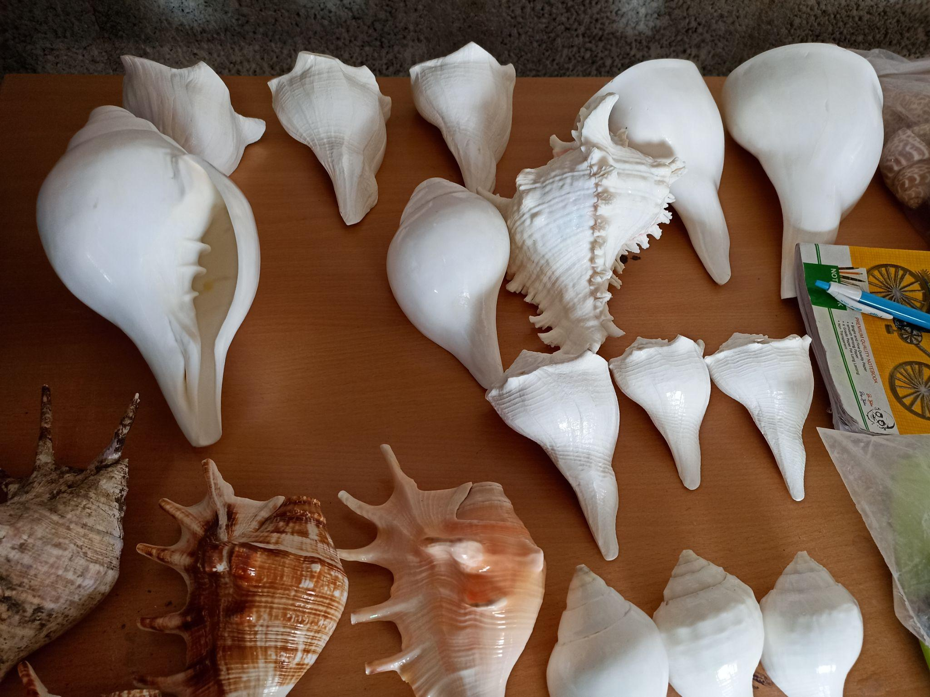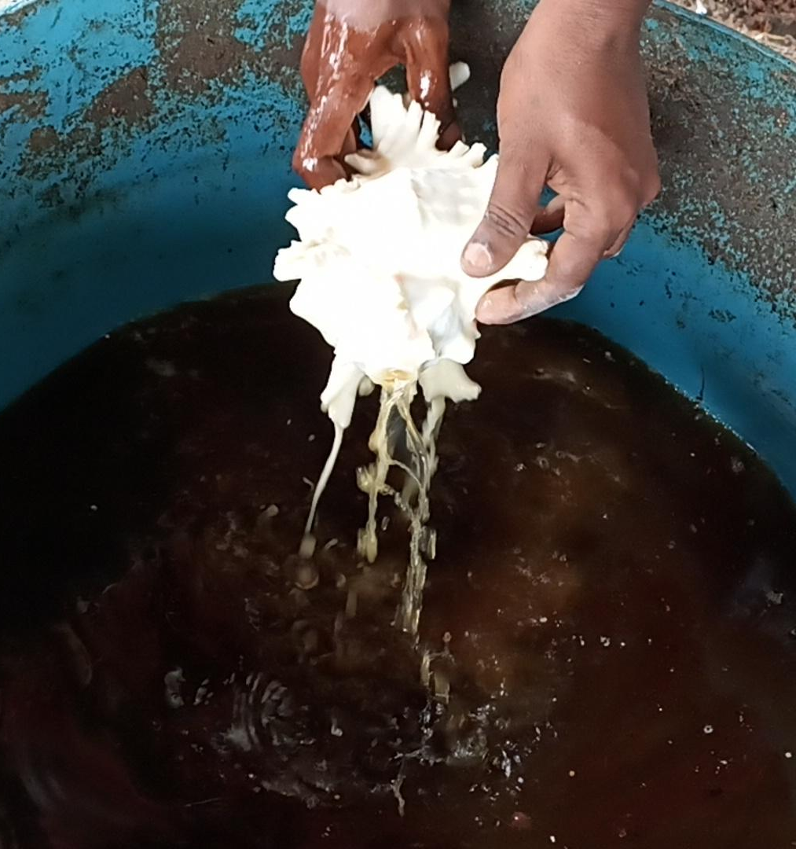
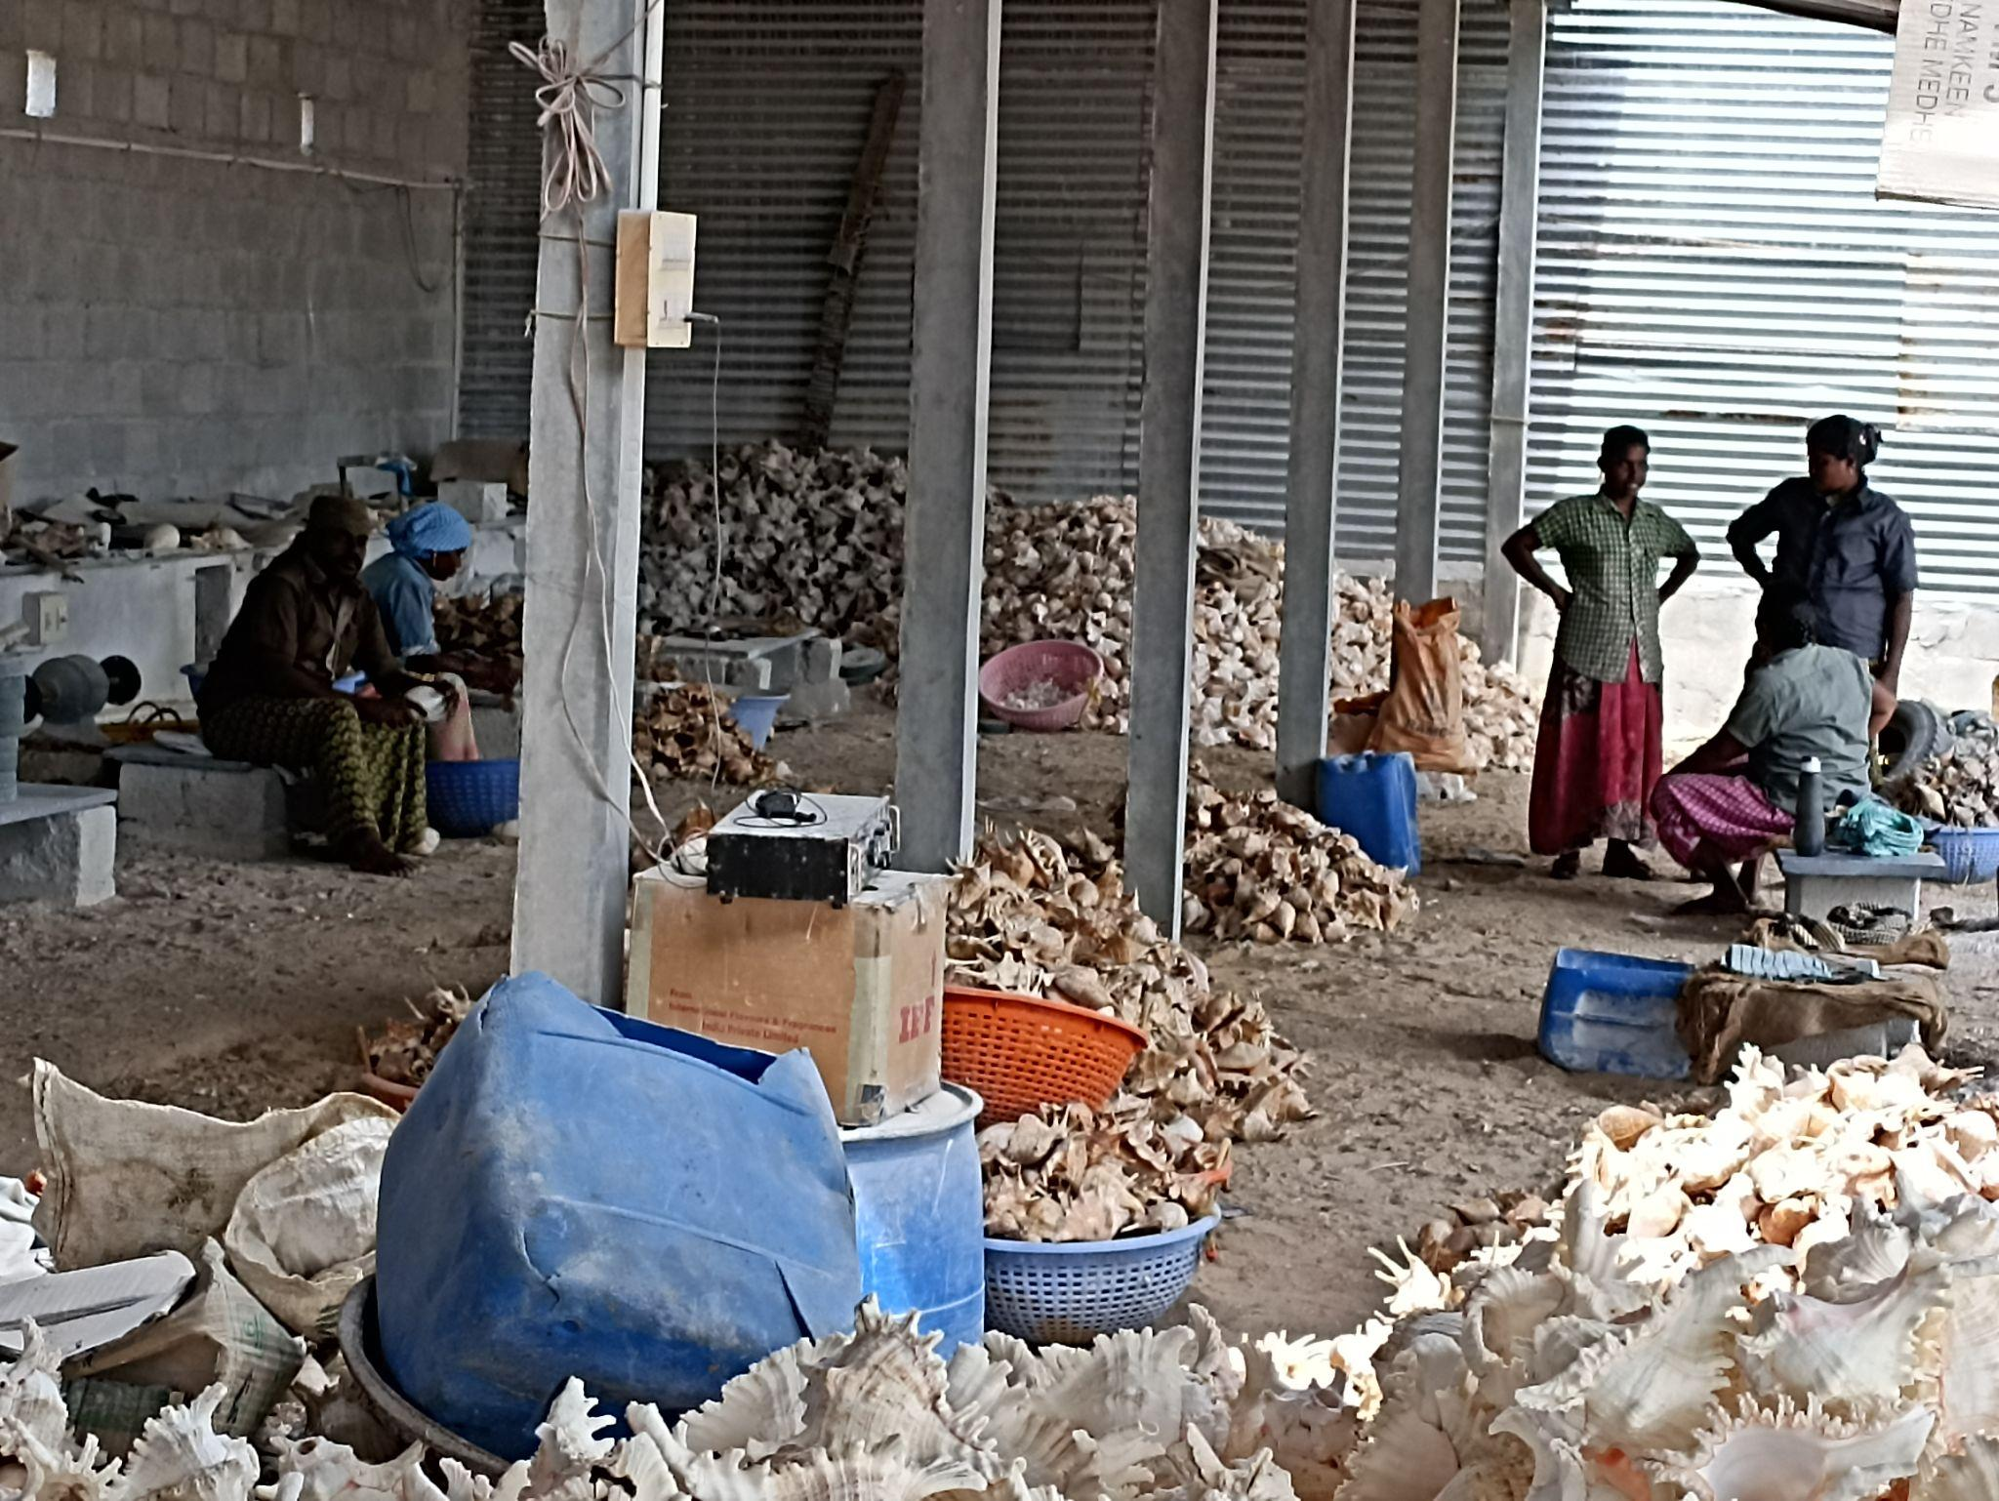

Women working in seashell cleaning unit
Village name: Hare Island Date: 19.08.2021
Block: Thoothukudi
Cluster: Fisheries
People of Hare island have been involved in the seaweed cultivation process for more than 20 years. Here in Thoothukudi they follow a method called Mono line net-bag method whereas in other parts of Tamil Nadu, people use bamboo raft method. Both men and women are involved in this process. The men get into the sea, plant the seaweed whereas women are involved in the pre and post processes including tying, drying and reading them for pick up.
Woman carrying seaweed Women tying the harvested seaweed
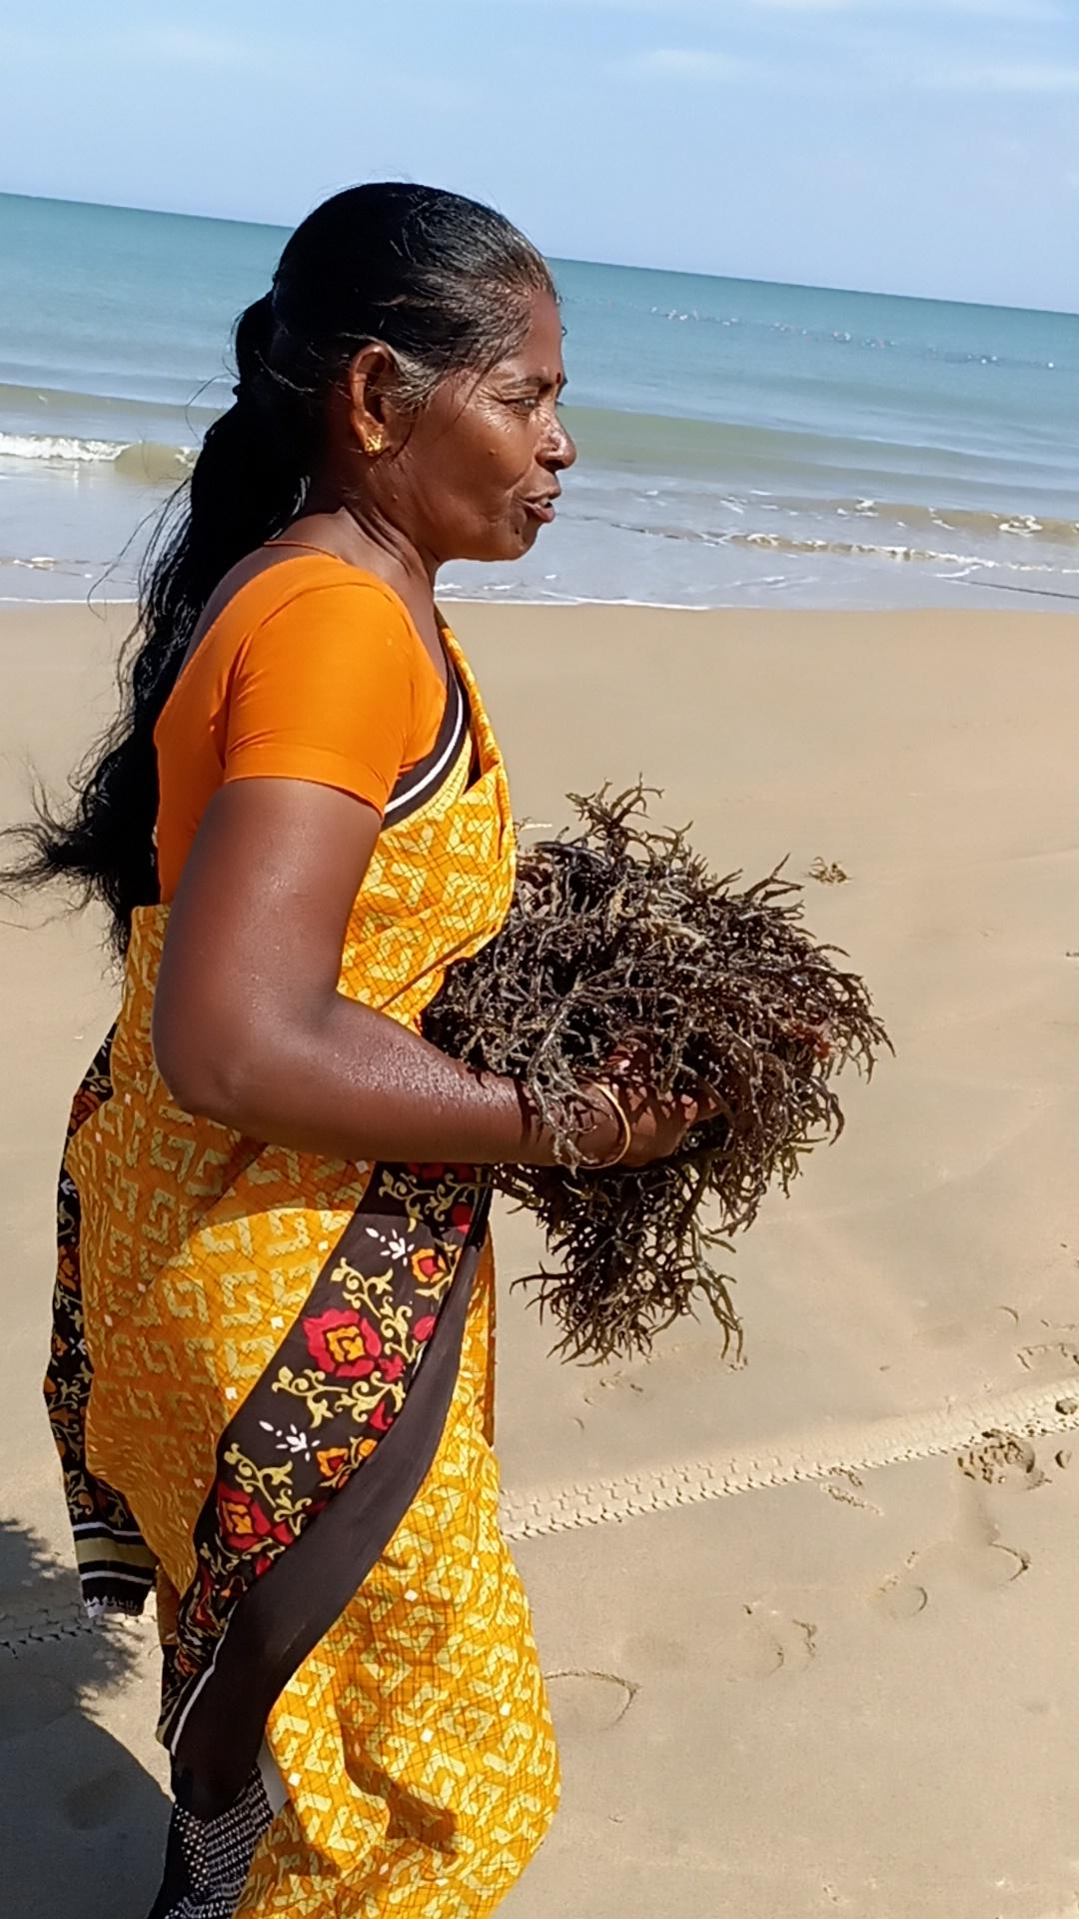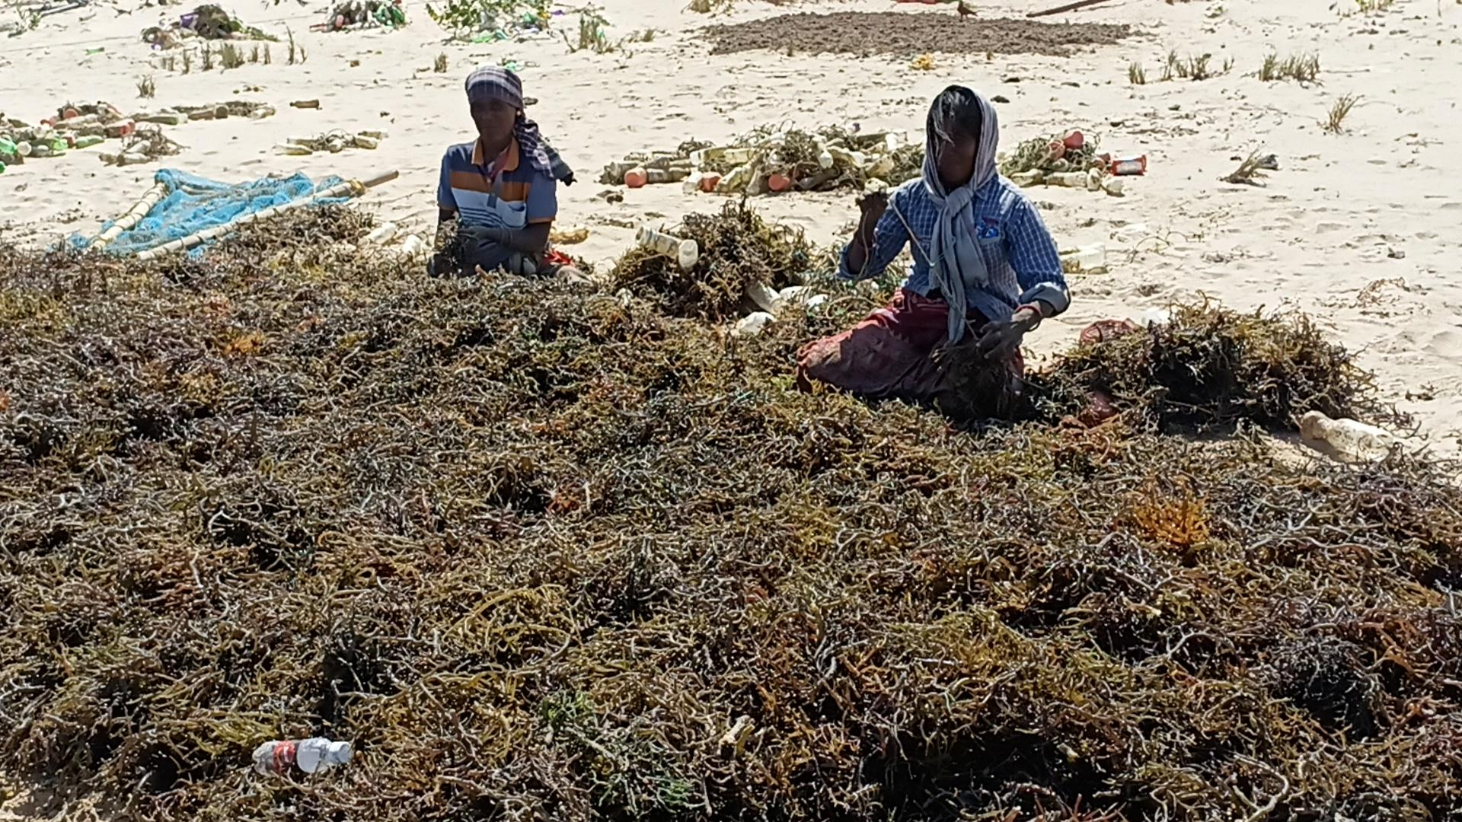
At present three private companies are involving people in this process. They provide them seeds and equipment for cultivation and then buy it from them at a minimum price of Rs.5/kg. The community requests that the government provide access to the seeds and equipment so that they can sell it directly to markets and give them access to value addition processes which will provide them more profit.

Village Name: Manapad Date: 20.08.2021
Block Name: Udangudi
Cluster: Handicraft
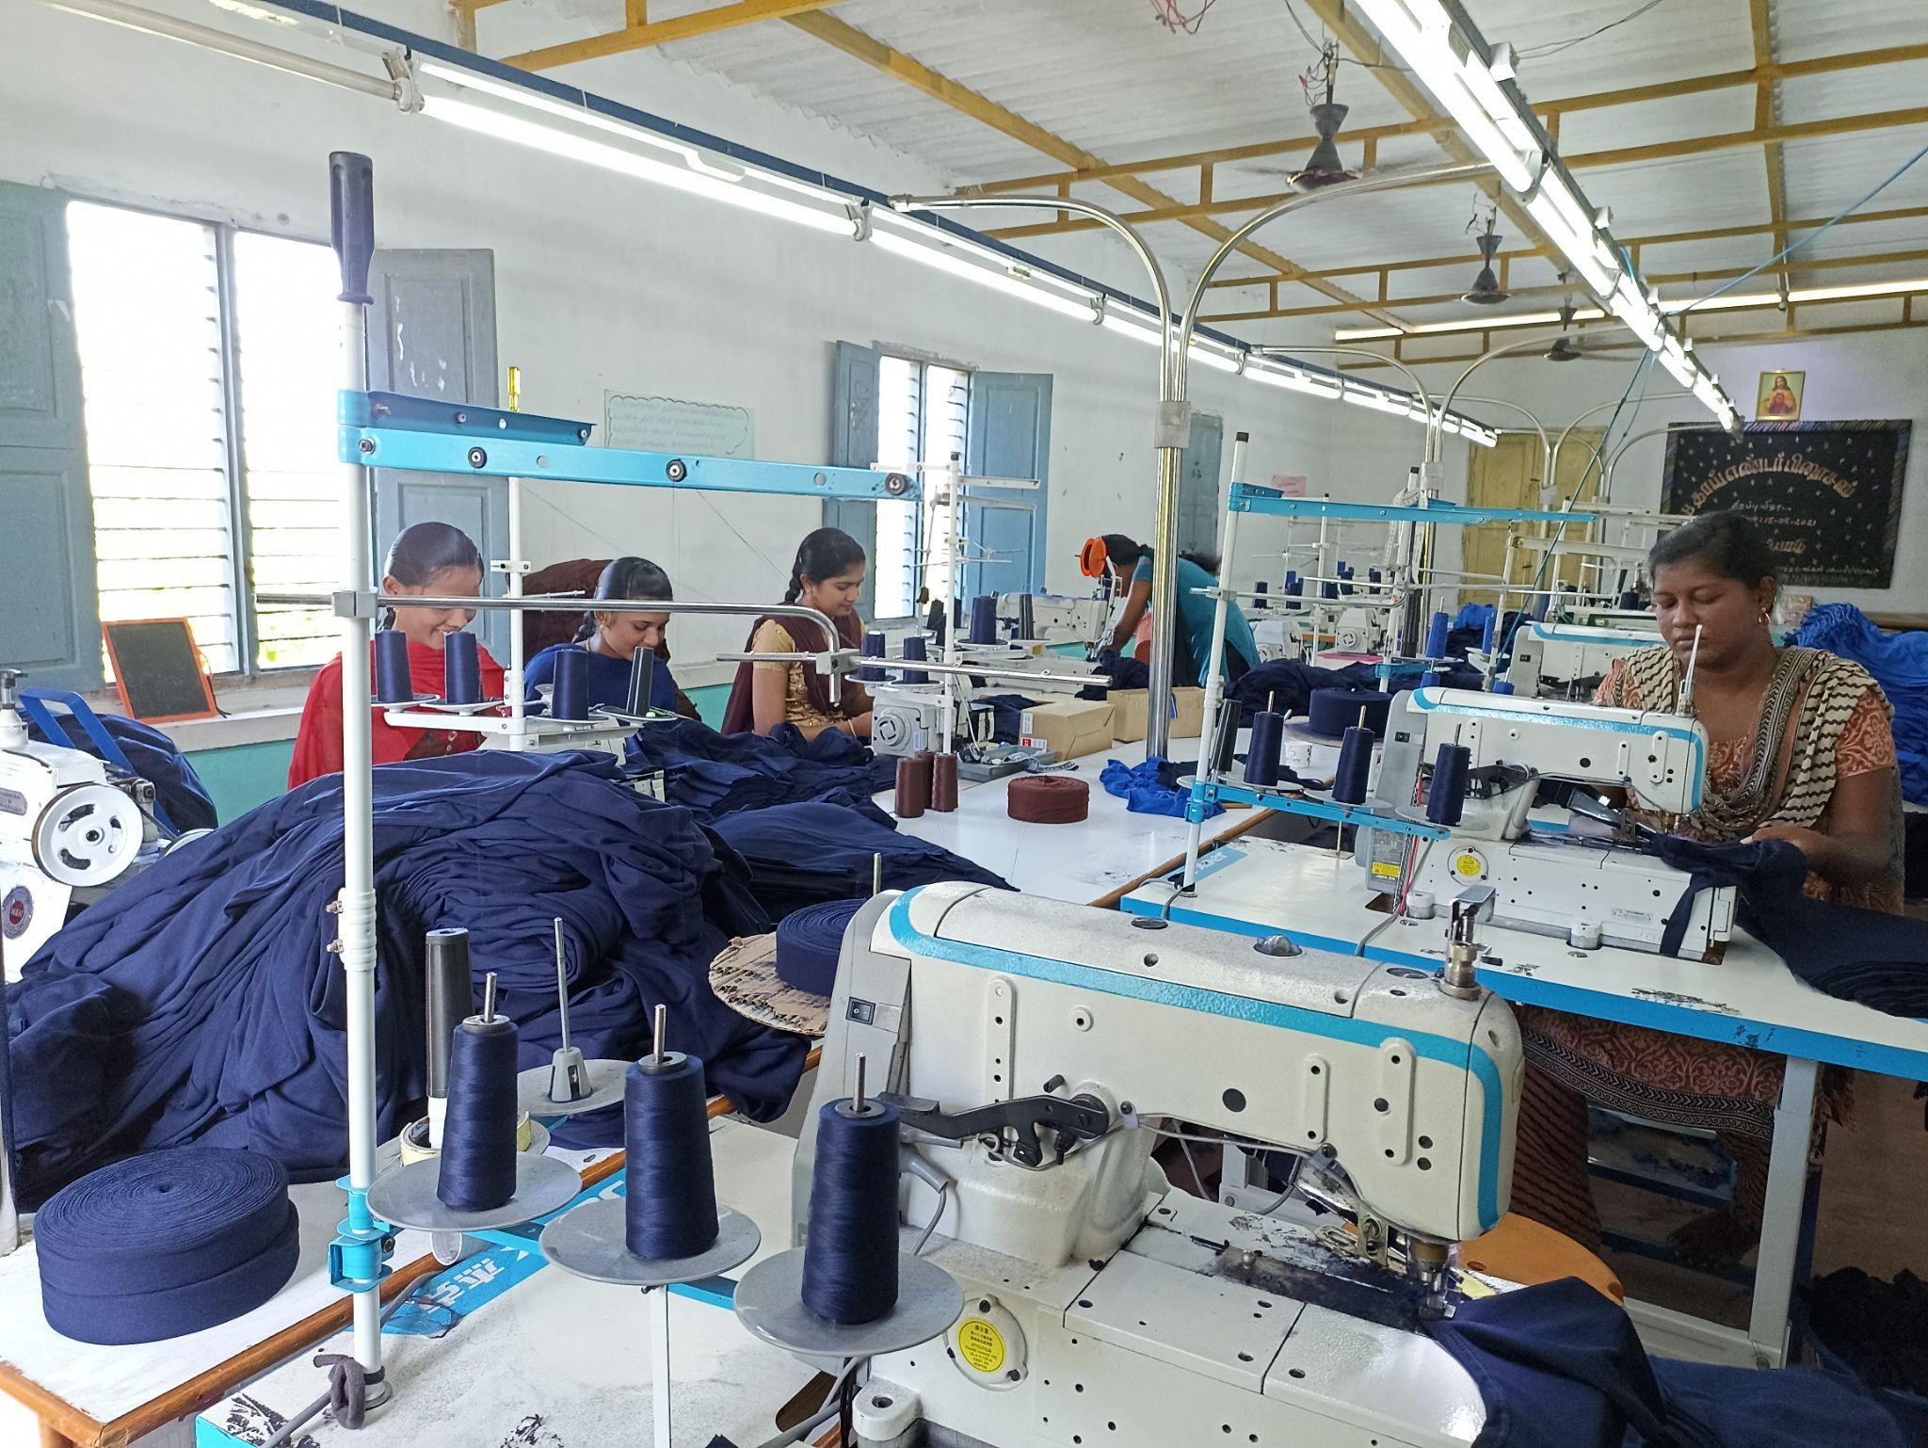
Manapad Garments unit
Manapad is one of the historic places which served as a busy trading port for merchants during the colonial era. At present, 1200 families are living in the village and their major occupation is Fishing. They have established a garment making unit with the funds provided by local people in their own village to provide employment opportunities for women. At present, 40 women employees are working in the Garment unit. They need access to raw materials within the district, whereas now they are getting it from Thirupur which takes a huge transportation cost. There is also an opportunity to utilise the rags from this unit for making mats and other such products involving women in SHGs.
Village Name: Sippikulam Date: 22.08.2021
Block Name: Vilathikulam
Clusters: Fisheries
Sippikulam is a coastal village where 5 families are involved in Cage Fish Farming under the SBGF (State Balanced Growth Fund) programme, Department of Fisheries. They feed the fish everyday from the larval stage and once it is fully grown, they sell it in the market for a good price. Both men and women are involved in this process. We witnessed a new technical contraption made by the son of a fisherman to feed the fishes. An ITI student, he had created a fish feeder that drastically reduced the number of trips they had to make into sea to feed the fish, as a result reducing their diesel and labour costs. This proves that collaboration of skillful youth from the primary stakeholder groups with the government can steer innovation and improve in these interventions.
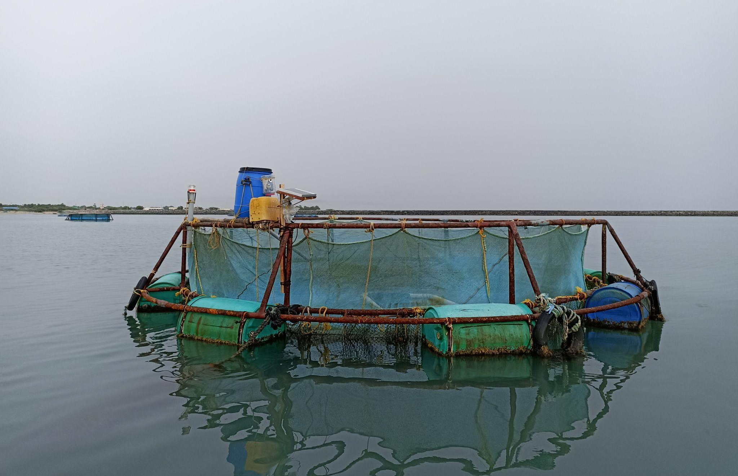
Cage Fish Farming
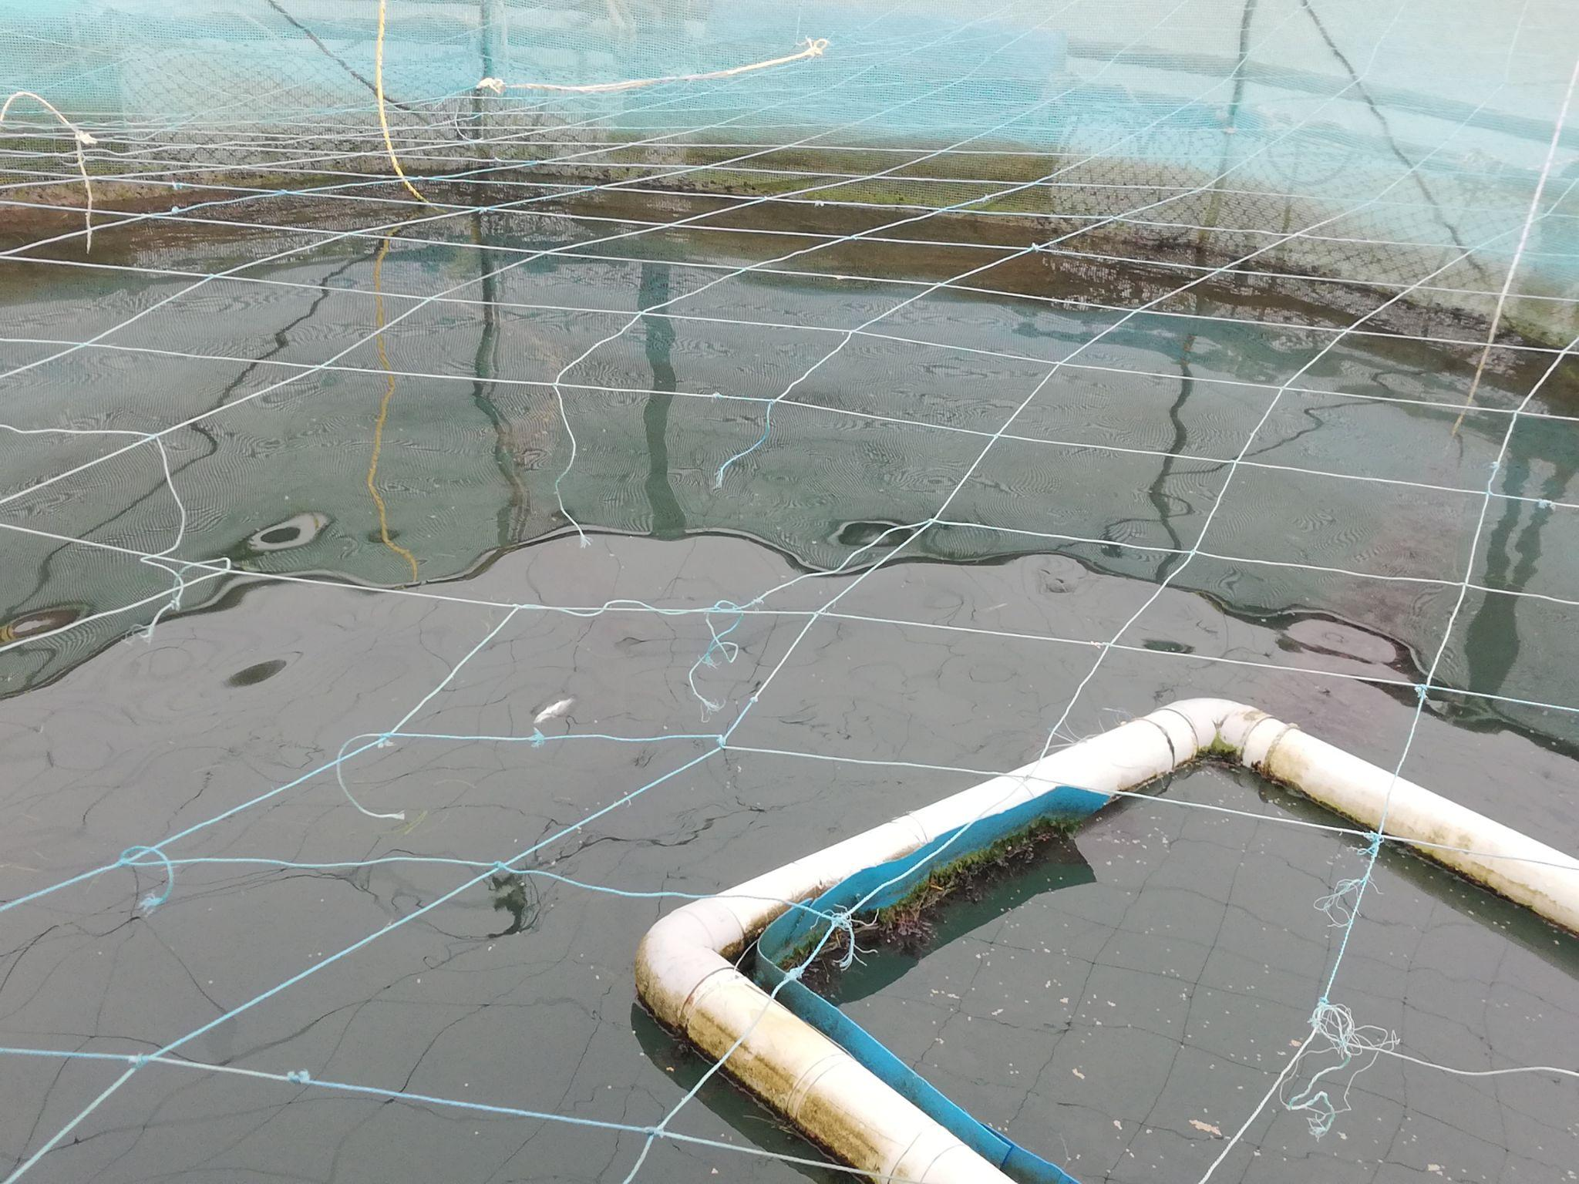
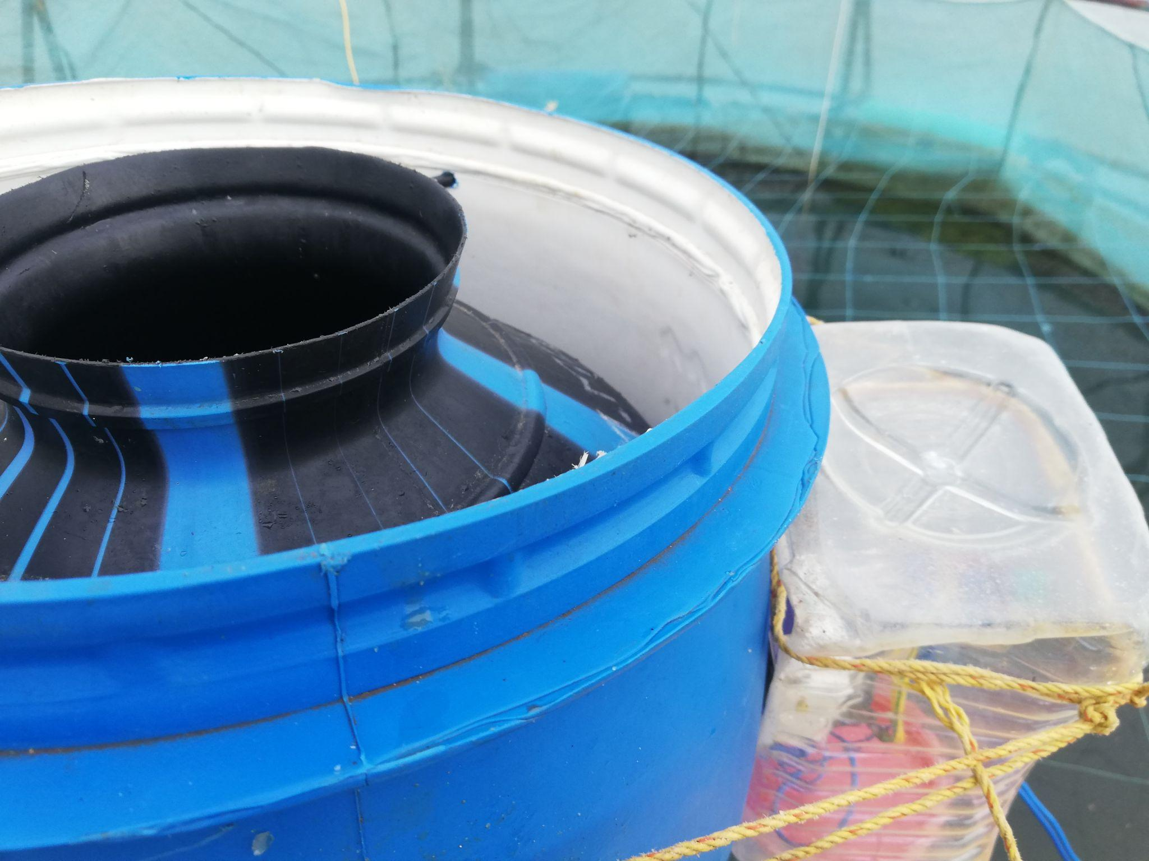
New technology introduced by a fisherman to feed fish in the cage

INDUSTRIAL VISITS:
On 17.08.2021, our team along with Mr. Srutanjay Narayanan IAS, Assistant Collector (Trainee), Thoothukudi District, members from MABIF and NABARD visited Kadalai Mittai industries and Match stick industries at Kovilpatti to get insights about the GI process. A considerable number of kadalai mittai units are cottage industries and more than 75 percent of the employees working here are women. It was noted that women are paid half the wages as men to do the same tasks. There's no single unit which is completely owned or run by women. The team along with the officials also had a meeting with the society of kadalai mittai industry owners and the society of match industries owners. They spoke about the development plans that can be made in the respective fields including creating better access to raw material and availability of labour.
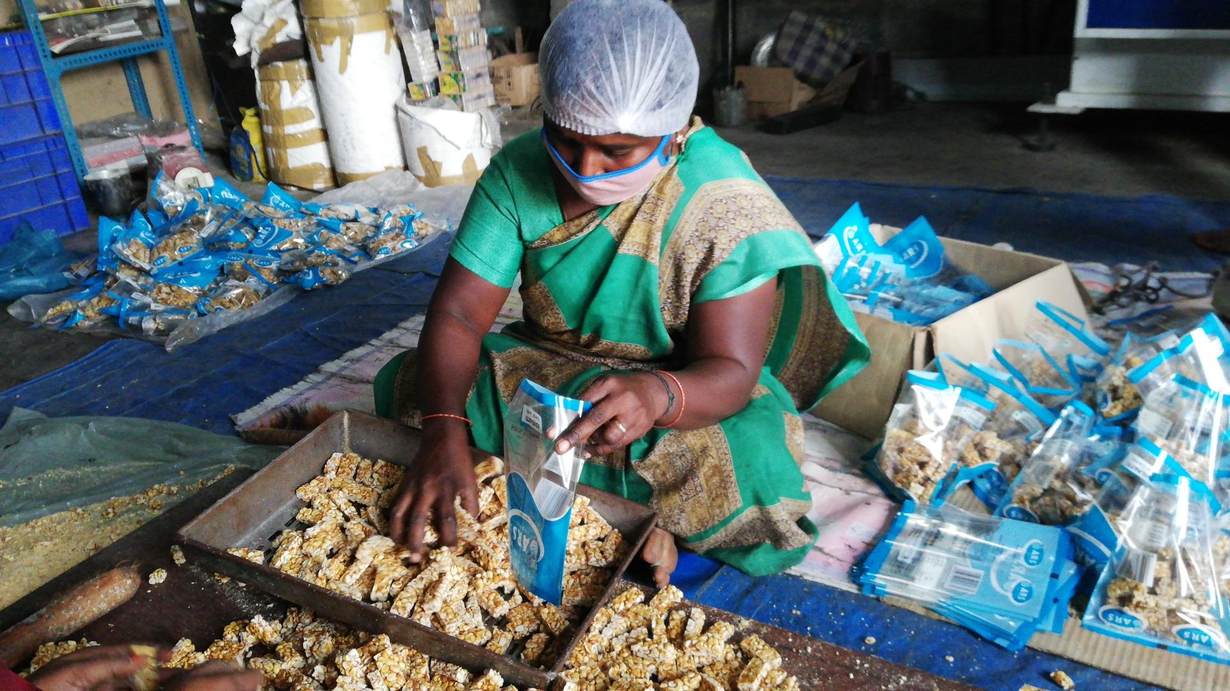
Woman working in Kadalamittai industry

INSTITUTIONAL VISITS:
On 14.08.2021, our team met with officials from the Department of Fisheries to discuss the interventions that can be initiated in the fisheries clusters. They elaborated on the existing programmes of fisheries to benefit the fishing community and also spoke about the possible ways to apply the objectives of the Reimagining Women Empowerment program among fisherfolk in Thoothukudi district.
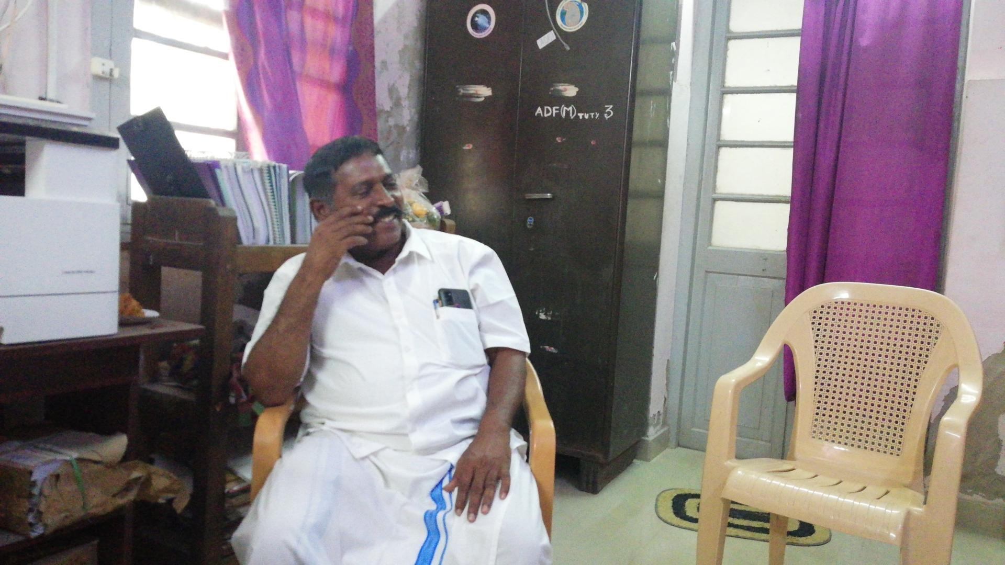
Mr. Issaci Muthu, fishermen showcased Amba paatu
On 19.08.2021, our team met enthusiastic fisher community men at the Department of Fisheries. Mr. Issaci Muthu, President of Sangukuli Meenavar Sangam, showcased Ambaa paatu, a folk tradition that belongs to the fishing community. The group of fishermen who involve themselves in shore seine fishing als sang for us and spoke about their culture and their traditional way of fishing as well.

OFFICIAL MEETINGS:
On 13.08.2021, before reaching the field, we met Dr. Senthil Raj IAS, District Collector, Thoothukudi and Mr. Srutanjay Narayanan IAS, Assistant Collector (Trainee). We explained the purpose of our visit. The team and the administrators were on the same page about the vision of the project. The discussions were about possible ways to combine the common vision with existing government programmes.
On 18.08.2021, the team met with Ms. Kanimozhi Karunanidhi, MP, Dr. Senthil Raj IAS, District Collector and Mr. Srutanjay Narayanan IAS, Assistant Collector (Trainee), members from NABARD, MABIF and PD Magalir Thitam. The discussion was about the findings of the pilot visit. Our team presented field observations and assessments during the meeting. The MABIF team presented the GI process and the possible items that can be applied for getting GI tag in the district.
At the meeting it was in principle agreed that Kaani Nilam & YPP will work along with the district administration and all existing relevant programmes to involve stakeholders and co-create an integrated digital and physical marketplace for women produced artisanal products of Thoothukudi. As part of the intervention, community women and youth leaders will be identified and they will be given capacity building and equipped with branding and marketing skills.
On 21.08.2021, we met Dr. Senthil Raj IAS, District Collector, Mr. Srutanjay Narayanan IAS, AC (trainee), Mr.Saravana IAS, PD-DRDA and Ms. Charusree IAS, Corporation Commissioner, Thoothukudi and discussed the next steps towards initiating the project. The administrators suggested starting the project with a few sample products such as palm crafts, pottery and agri value added products. By the end of the meeting the District administrators agreed to provide complete support to this initiative.

ACTION PLAN:
- Bring together women-led clusters from various overlapping programmes like TNRTP, MaThi, SBGF, etc, and classify them within our programme as clusters with indigenous skills and acquired skills to co-develop targeted interventions
- Document oral histories and cultural memories to support product development, marketing and sales
- Facilitate inter-generational and intercommunity dialogue
- Product intervention - product diversification, better product development, standardisation, quality control, etc,.
- Identify and iron out supply chain issues and co-create systems for future management
- Identify subject matter experts and create collaborative efforts to build integrated digital and physical marketplace
- Capacity building in women to understand and better interact with the market - finance, business, collectivisation, access to entitlements, etc.
- Cultivate ownership and leadership in women stakeholders for sustainability
- Transfer of management to stakeholders post initial hand-holding

